

Database Design and Implementation

MOD002589

Faculty: Science and Technology

Department: Computing and Technology

**Prepared by: Muhammad Ameer Hamza**

**SID:______**

Academic Year: 2023/24

Trimester: 1

Contents

1. Requirement Analysis 6

Abstract 6

1.1 Description of the three websites chosen 6

1.1.1 Amazon UK 7

1.1.2 eBay UK 7

1.1.3 Walmart US 7

1.2 List of data fields (Entities and their attributes) 7

1.2.1 List of data fields from Amazon UK 8

1.2.2 List of data fields from eBay UK 8

1.2.3 List of data fields from Walmart US 9

1.3 Finalised List 9

1.3.1 The generic list 9

2. Database design 12

2.1 Entity Relationship Modelling 12

2.1.1 Initial Entity Relationship Model 12

2.1.2 Extended Entity Relationship Model 13

2.2 Normalised Model 15

2.3 Database Schema 16

3. Database implementation 20

3.1 Table Creation 20

3.2 Referential Integrity Enforcement 27

3.3 Sample Data Insertion 28

3.4 Relationship Validation 36

4. SQL Queries 37

4.1 Query 1 37

4.1.1 Purpose 37

4.1.2 Natural language 37

4.1.3 SQL Code and output 37

4.1.4 Explanation 39

4.2 Query 2 39

4.2.1 Purpose 39

4.2.2 Natural language 39

4.2.3 SQL Code and output 39

4.2.4 Explanation 40

4.3 Query 3 40

4.3.1 Purpose 41

4.3.2 Natural language 41

4.3.3 SQL Code and output 41

4.3.4 Explanation 42

4.4 Query 4 42

4.4.1 Purpose 42

4.4.2 Natural language 43

4.4.3 SQL Code and output 43

4.4.4 Explanation 44

4.5 Query 5 44

4.5.1 Purpose 45

4.5.2 Natural language 45

4.5.3 SQL Code and output 45

4.6 Query 6 46

4.6.1 Purpose 47

4.6.2 Natural language 47

4.6.3 SQL Code and output 47

4.6.4 Explanation 48

4.7 Query 7 48

4.7.1 Purpose 48

4.7.2 Natural language 49

4.7.3 SQL Code and output 49

4.7.4 Explanation 50

4.8 Query 8 50

4.8.1 Purpose 51

4.8.2 Natural language 51

4.8.3 SQL Code and output 51

4.8.4 Explanation 52

4.9 Query 9 52

4.9.1 Purpose 52

4.9.2 Natural language 53

4.9.3 SQL Code and output 53

4.9.4 Explanation 54

4.10 Query 10 54

4.10.1 Purpose 54

4.10.2 Natural language 55

4.10.3 SQL Code and output 55

4.10.4 Explanation 56

5. References 56

# Requirement Analysis

## ****Abstract****

This report is about end-to-end development of a prototype small commercial database system that can be used for online shopping. Starting with an investigation into the three largest UK and US e-commerce websites: Amazon UK, eBay UK and Walmart US where we identify all the entities and attributes associated with the process of customer-ordering. A comprehensive list of fields is generated from this base in order to create an Extended Entity Relationship Diagram (EERD). The objective of the report is not only to show technical knowledge, but also to show analysis by abstraction and industry relevancy into the development of database models.

## 1.1 Description of the three websites chosen

To accurately model a real-world online shopping database, I analysed the interactive purchasing interfaces of three commercial retail platforms. These platforms were chosen due to their established reputations, complexity in order flow, and diversity in their approach to product listing, checkout, and delivery.

### 1.1.1 Amazon UK

Amazon UK ([https://www.amazon.co.uk](https://www.amazon.co.uk/)), besides the full purchasing experience with oneclick order, multi-address delivery, Prime, and coupon application, the support for dynamic shipping windows is also provided. You have to go through a number of steps at checkout where you select your delivery, enter your payment and review your order. Amazon's design also indicates some hidden data flows, like checks for Prime eligibility and promotional tracking.

### 1.1.2 eBay UK

eBay UK – [https://www.ebay.co.uk](https://www.ebay.co.uk/) eBay UK is a combination of an auction site and a shopping site. While the focus of this work is on ‘Buy It Now’ features, The existence of further attributes i.e. ‘Make an Offer’, feedback scores, and seller specific delivery rules further complicates the organisation. Payment options differ, with PayPal connectivity as an option. Buyers can also contact sellers by leaving messages for them, which adds another level of interaction.

### 1.1.3 Walmart US

Walmart ([https://www.walmart.com](https://www.walmart.com/)) offers a distinctive omnichannel experience, with the ability to pick up in store, schedule delivery or choose substitution for out-of-stock items. At checkout, users also choose delivery slots, add tips for drivers and verify mobile numbers for curbside pickup. This information suggests rather complex backend needs for monitoring time-slot and status.

## 1.2 List of data fields (Entities and their attributes)

These attributes were identified through analysis of source code, user interface elements, and inferred user **behaviour** for performing a checkout in the storefronts of the respective websites. Hidden or system-generated values were emphasized to allow richer **modelling** of entities.

### 1.2.1 List of data fields from Amazon UK

* Email Address
* Password
* First Name
* Last Name
* Delivery Address (Street, City, Postcode, Country)
* Billing Address
* Prime Eligibility (Boolean)
* Gift Wrap Option (Boolean)
* Promo Code (Text)
* Loyalty Points Applied (Number)
* Card Type (Enum: Visa, Mastercard, etc.)
* Card Last 4 Digits
* Expiry Month / Year
* CVV Code
* Selected Delivery Speed
* Device Type (Mobile/Desktop - inferred)
* Session Token (hidden)
* Referral Source (Affiliate links - hidden)

### 1.2.2 List of data fields from eBay UK

* Shipping Address
* Billing Address
* Contact Phone Number
* Seller ID
* Seller Rating
* Delivery Service Option
* Quantity
* Note to Seller
* VAT Registration Number
* Payment Method Type
* Coupon Code
* Charity Donation (Yes/No)
* Auction Expiry Time (used even for ‘Buy Now’)
* Feedback Opt-In (Yes/No)
* Session Cart ID
* Mobile App Version (if used - tracked internally)

### 1.2.3 List of data fields from Walmart US

* Email Address
* Password
* Delivery Address or Store Pickup Location
* Phone Verification Code (SMS)
* Substitution Permission (Boolean)
* Loyalty ID (Walmart Rewards)
* Scheduled Delivery Slot
* Payment Method
* Delivery Tip Amount
* Delivery Fee Estimate
* Device Used
* Geo Location (Browser enabled - approximate coordinates)
* Curbside Verification Code
* Cart Weight (for delivery planning)
* Time-to-Cart Abandonment (internally tracked)
* Estimated Order Total

## 1.3 Finalised List

These three lists were processed, commonised and collected together to form a set of attributes that covered the most of the operational and the customer services. Hidden or inferred fields were kept in the schema for more complex querying and analysis.

### 1.3.1 The generic list

Below is the consolidated entity and attribute structure to be used in the database design:

**Customer**

* CustomerID
* FirstName
* LastName
* Email
* PhoneNumber
* LoyaltyID
* PreferredDevice
* CustomerStatus (Active, Churned)

**Address**

* AddressID
* CustomerID (FK)
* Street
* City
* State
* Postcode
* Country
* AddressType (Billing, Delivery, Pickup)

**Seller**

* SellerID
* SellerName
* SellerRating
* ContactEmail
* ContactPhone

**Product**

* ProductID
* ProductName
* Description
* UnitPrice
* StockQty
* SellerID (FK)

**Category**

* CategoryID
* CategoryName

**ProductCategory** *(Bridge Table)*

* ProductID (FK)
* CategoryID (FK)

**Order**

* OrderID
* CustomerID (FK)
* DeliveryAddressID (FK)
* OrderDate
* DeliveryType (Pickup, Delivery)
* SubstitutionAllowed
* DeliverySlot
* Status (Pending, Shipped, Delivered, Cancelled, Refunded)

**OrderItem**

* OrderID (FK)
* ProductID (FK)
* Quantity
* ItemPrice (Captured at time of order)

**PaymentMethod**

* PaymentMethodID
* MethodName (Card, PayPal, Cash, Wallet)

**Payment**

* PaymentID
* OrderID (FK)
* MethodID (FK)
* PaymentDate
* PaymentStatus (Paid, Refunded, Failed)
* Amount
* CardLast4

**Note**: *This structure is an abstraction of characteristics of visible fields, user input and implied operations from backend. and also supports features like fraud analysis or fulfilment prediction. The attribute richness allows a higher complexity in the later ERDs and queries*.

# 2. Database design

## 2.1 Entity Relationship Modelling

### 2.1.1 Initial Entity Relationship Model

Before building the full extended model, a basic ERD was created involving three core entities: **Customer**, **Product**, and **Order**. This early prototype helped identify that:

* An **Order** can contain **multiple products**
* A **Product** can belong to **multiple categories**
* A **Customer** can place **multiple orders**

This initial structure helped validate the required relationships and provided a foundation for a more robust EERD.

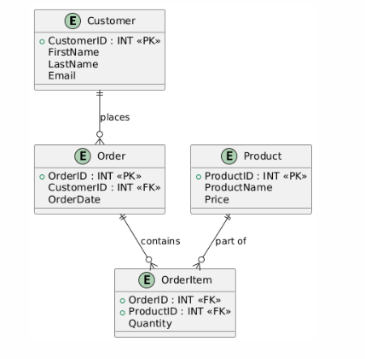

### 2.1.2 Extended Entity Relationship Model

The final Extended Entity Relationship Diagram (EERD) includes ten fully normalised entities. The diagram incorporates advanced EER notation and models complex business logic drawn from the requirements analysis.

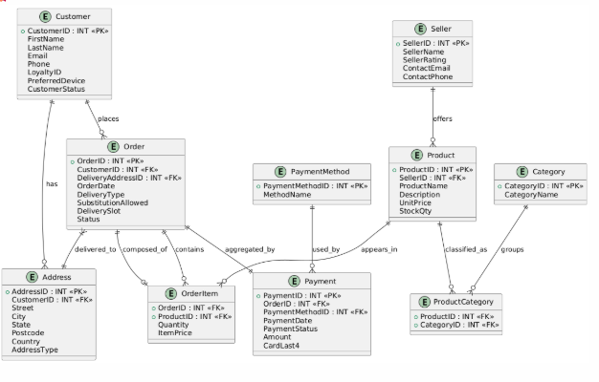

**Full EER Diagram**

**Note: workbench ERD screenshot added in next headings**

##### Key features of the EERD(example just for explanation) :

* **Many-to-Many Relationship (M:N)**:
  + ProductCategory acts as a bridge between Product and Category.
  + Each product can belong to multiple categories, and each category can contain multiple products.
* **Composition (⧫)**:
  + Order ⧫─ OrderItem
  + Indicates strong ownership. If an Order is deleted, its OrderItems must also be deleted (ON DELETE CASCADE).
* **Aggregation (Double Rectangle)**:
  + Payment aggregates the Order.
  + Although Payment depends on the existence of Order, it is treated as a summarised transaction layer.
* **Weak Entities**:
  + OrderItem does not have a unique identifier of its own and instead uses a composite key: (OrderID, ProductID). It relies on its parent Order for identity.
* **Cardinality/Mappings shown explicitly**:
  + All relationships show 1:N, M:N, or 1:1 with crow’s foot notation and label lines.
  + Optional vs mandatory participation is shown using solid and dashed lines.

This diagram serves as the blueprint for schema development and implementation.

## 2.2 Normalised Model

All entities in the EERD have been evaluated and verified for **Third Normal Form (3NF)** and where applicable, **Boyce-Codd Normal Form (BCNF)**.

#### Normalisation Summary:

| **Table** | **NF Level** | **Justification** |
| --- | --- | --- |
| **Customer** | 3NF | No partial or transitive dependencies. Email is unique. |
| **Address** | 3NF | Depends fully on AddressID. CustomerID as FK. |
| **Seller** | 3NF | All attributes depend fully on SellerID. |
| **Product** | 3NF | StockQty, UnitPrice not derived from any other field. |
| **Order** | 3NF | DeliveryType, SubstitutionAllowed, Status are independent and non-transitive. |
| **OrderItem** | 3NF | Composite key: (OrderID, ProductID). All non-key attributes (e.g., Quantity, ItemPrice) are fully dependent. |
| **Payment** | 3NF | Depends only on PaymentID, no transitive dependencies. |
| **Category** | 3NF | Simple lookup table. |
| **ProductCategory** | 3NF | Composite PK; no extra attributes. |
| **PaymentMethod** | 3NF | Static list with no dependent attributes. |

##### Example: OrderItem

* Composite Key: OrderID, ProductID
* Non-key attributes: Quantity, ItemPrice
* All are dependent on the full key, not part of it
* No transitive dependency  
  → Confirmed: **3NF + BCNF**

## 2.3 Database Schema

The final schema includes **10 tables**, each defined with:

* Proper **Primary Keys (PKs)**
* **Foreign Keys (FKs)** that maintain referential integrity
* Appropriate **data types** (e.g., VARCHAR, INT, DECIMAL, ENUM)
* Use of **ENUMs** for constrained fields like Status, DeliveryType, PaymentStatus

#### Schema

| **Table** | **Primary Key(s)** | **Foreign Keys / Relationships** | **Notes & Data Types** |
| --- | --- | --- | --- |
| **Customer** | CustomerID (INT) | – | VARCHAR(100) for Email, LoyaltyID optional |
| **Address** | AddressID (INT) | CustomerID → Customer(CustomerID) | ENUM: Billing/Delivery |
| **Seller** | SellerID (INT) | – | Includes SellerRating (DECIMAL(2,1)) |
| **Product** | ProductID (INT) | SellerID → Seller(SellerID) | DECIMAL(10,2) for Price |
| **Category** | CategoryID (INT) | – | – |
| **ProductCategory** | ProductID + CategoryID | → Product, → Category | Composite PK |
| **Order** | OrderID (INT) | CustomerID, AddressID → Address(AddressID) | ENUMs for Status, DeliveryType |
| **OrderItem** | OrderID + ProductID | → Order, → Product | Quantity (INT), ItemPrice (DECIMAL) |
| **PaymentMethod** | MethodID (INT) | – | Static Table (e.g., Card, PayPal) |
| **Payment** | PaymentID (INT) | OrderID, MethodID → PaymentMethod(MethodID) | ENUM for Status (Paid, Refunded, Failed) |

#### Constraints and Integrity

* All FKs are enforced with **ON DELETE RESTRICT** or **CASCADE** (for compositions).
* Data types were chosen to **match domain expectations**, e.g.:
  + StockQty: INT
  + UnitPrice: DECIMAL(10,2)
  + Status: ENUM('Pending', 'Delivered', 'Cancelled')

#### Implementation Note:

The schema was created using **XAMPP software**, and later **exported and executed** as .sql script. Screenshots from the implementation phase are included in Section 3.

# 3. Database implementation

The complete schema outlined in Section 2 was implemented in **XAMPP** .All tables were created through SQL CREATE TABLE statements, respecting the constraints, relationships, and data types defined in the design phase.

## 3.1 Table Creation

All ten tables were created with:

* Accurate primary and foreign key constraints
* Appropriate data types (INT, VARCHAR, DECIMAL, ENUM, DATE)
* Cascading deletes configured for child entities such as OrderItem

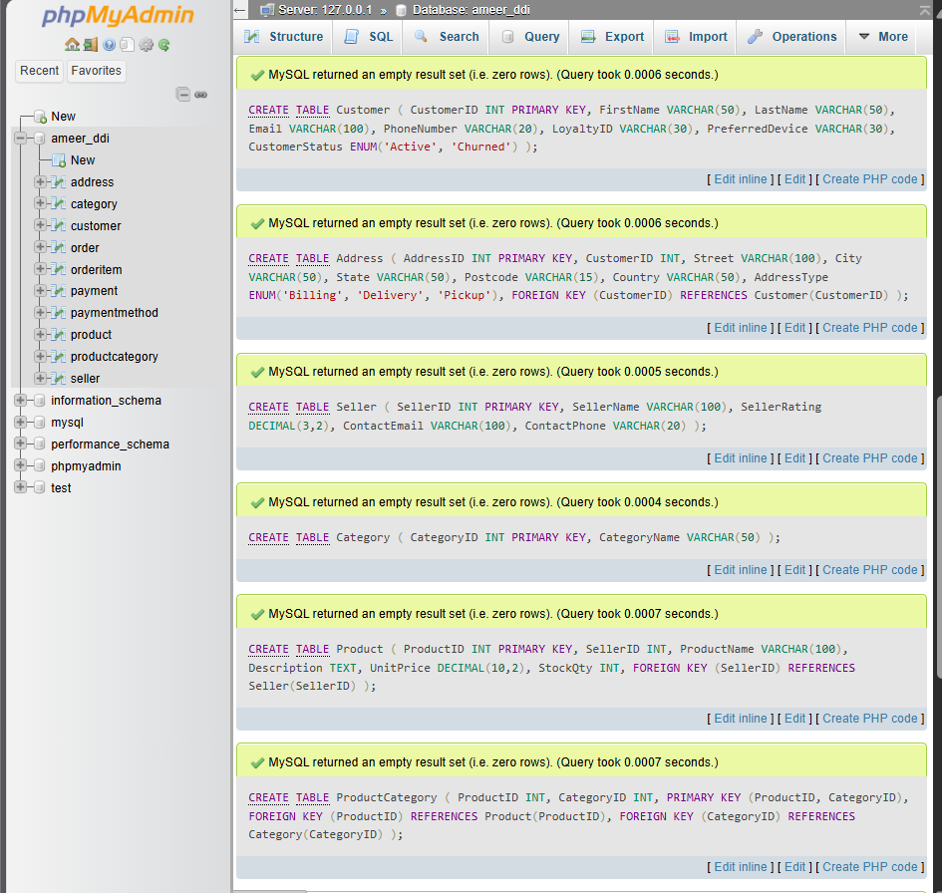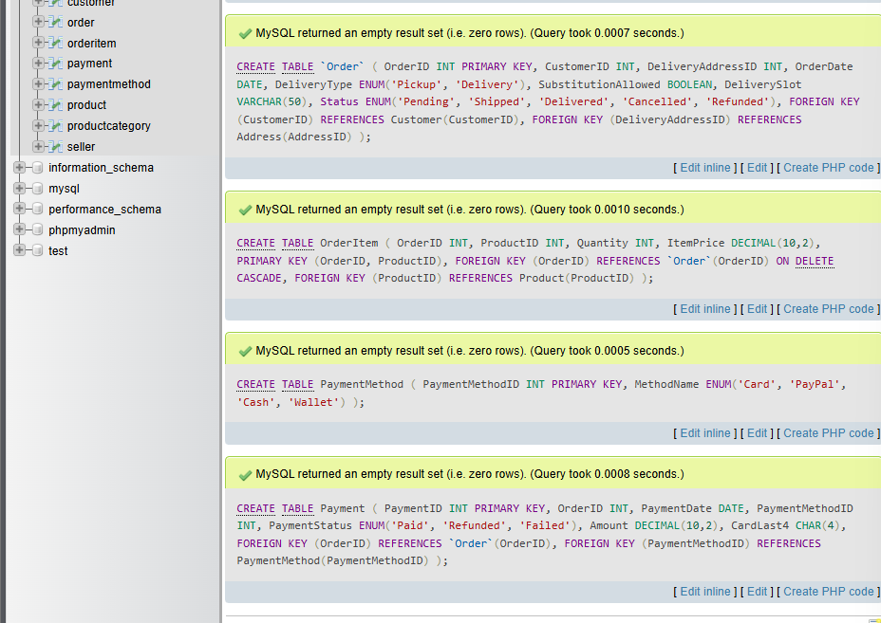

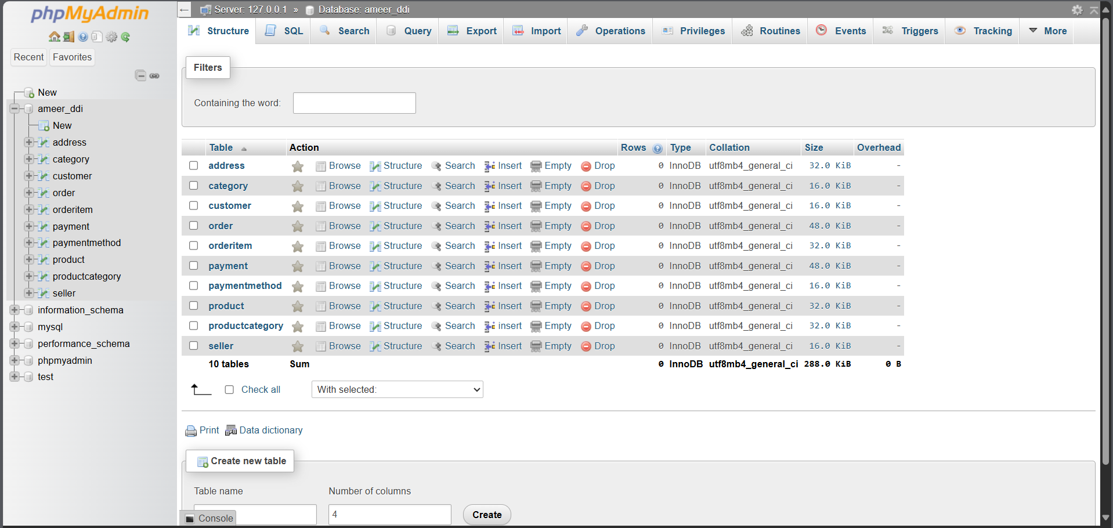

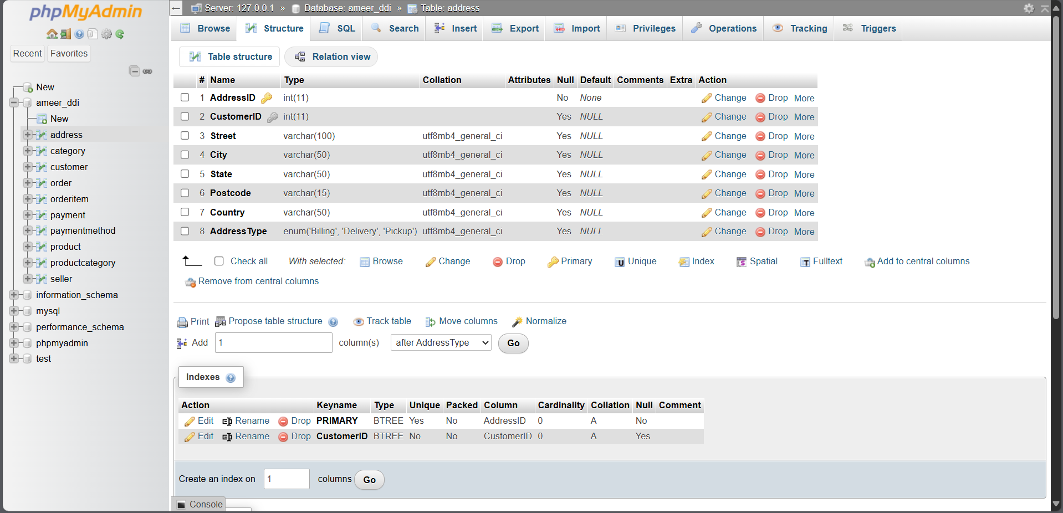

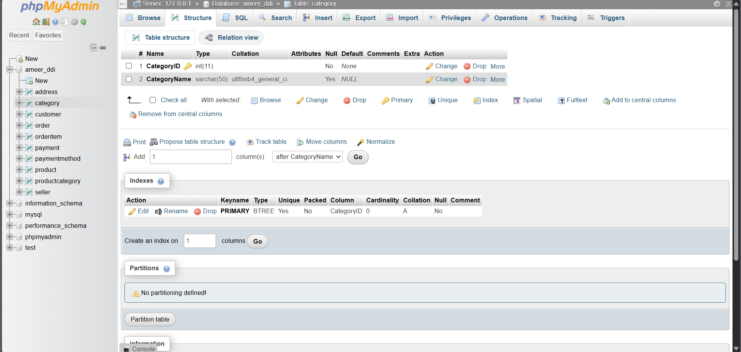

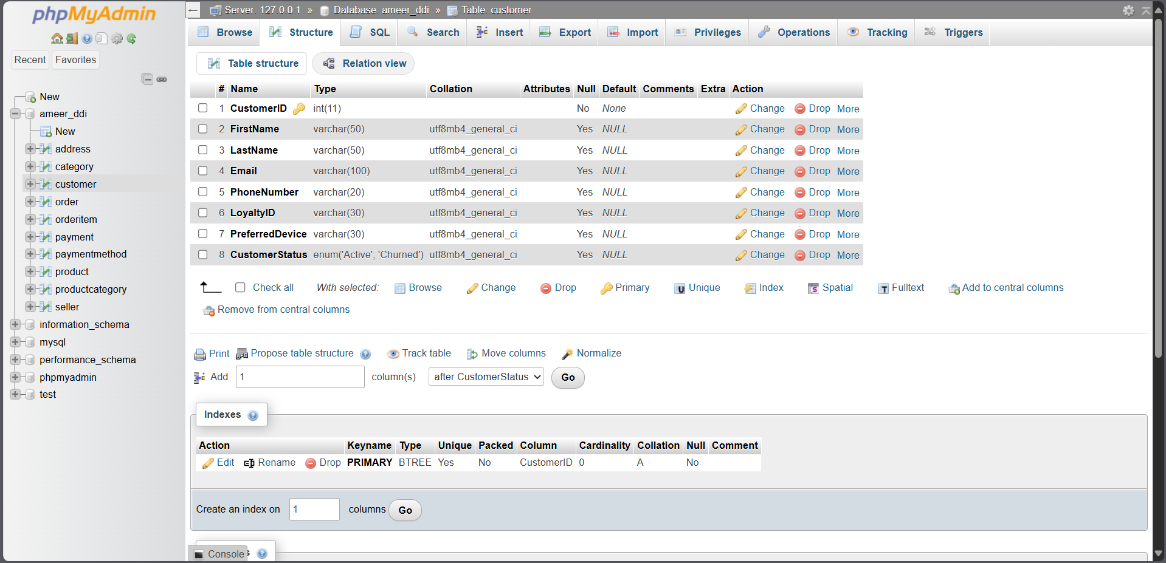

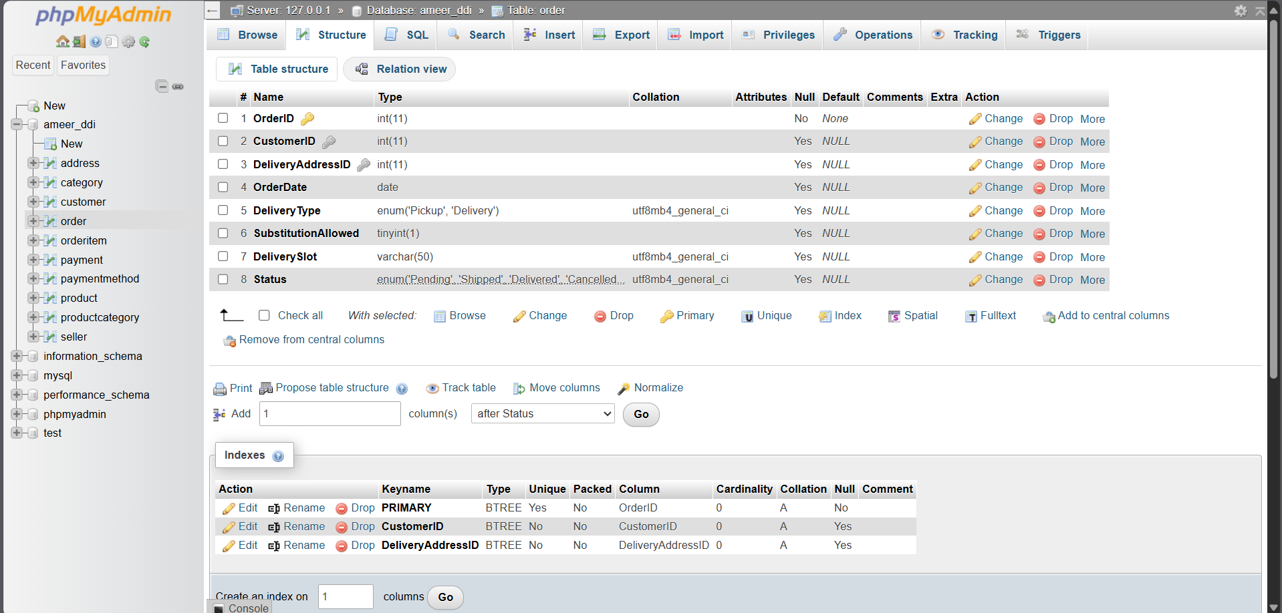

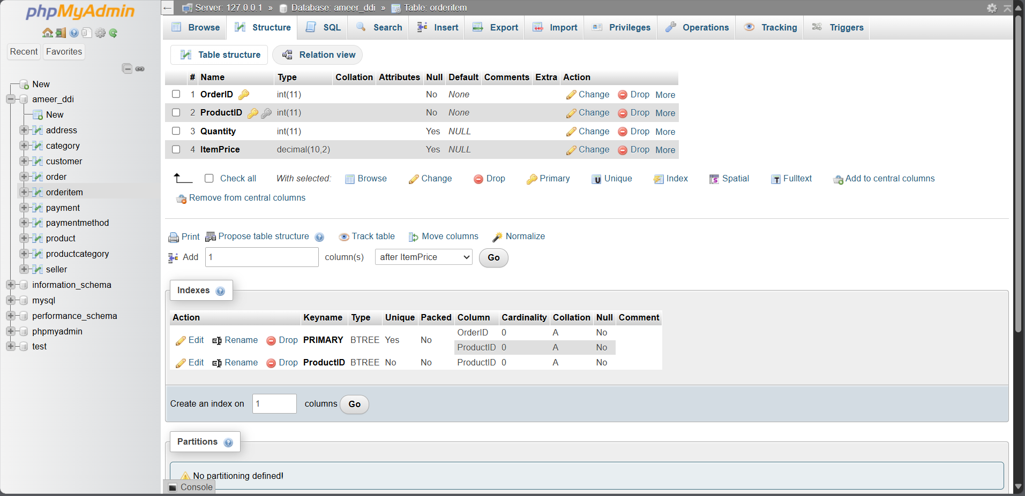

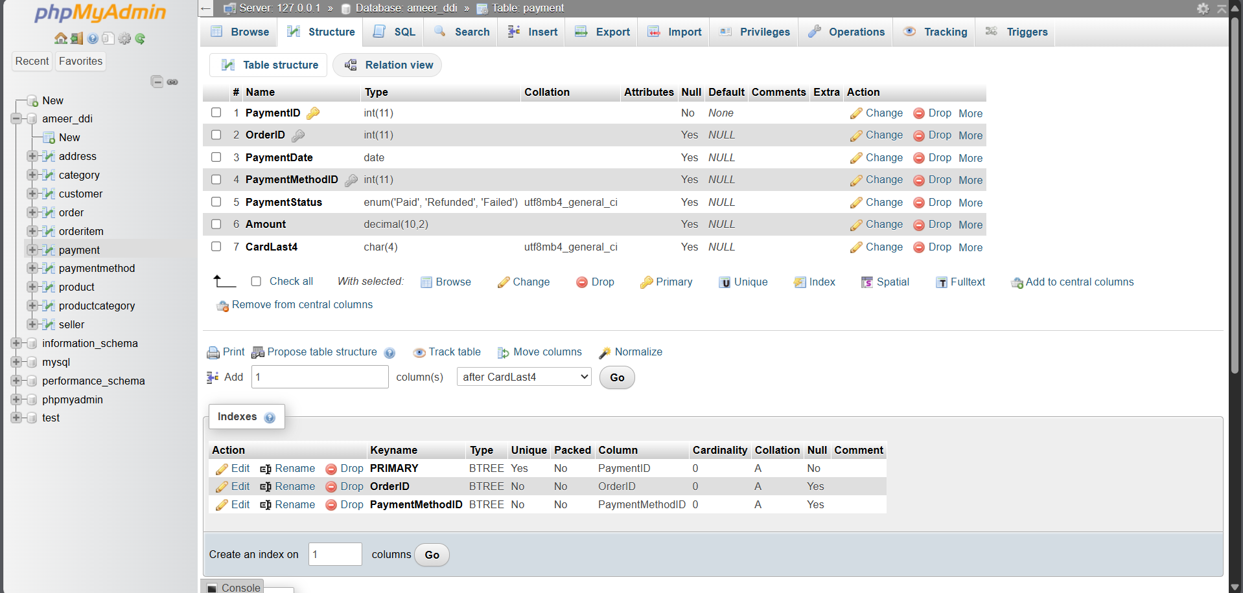

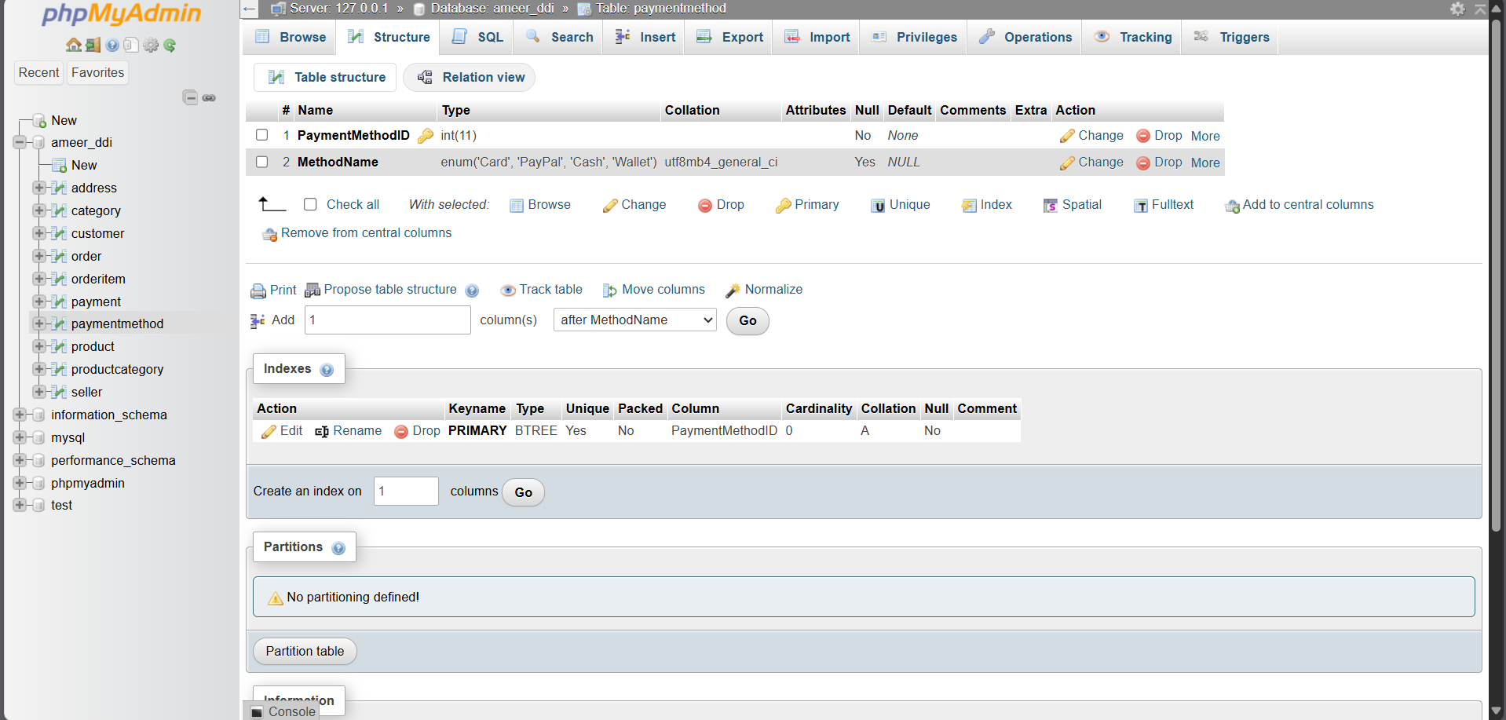

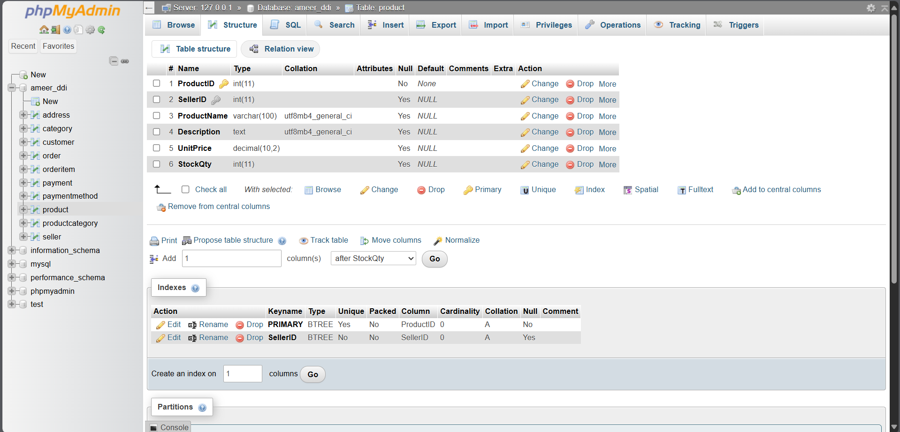

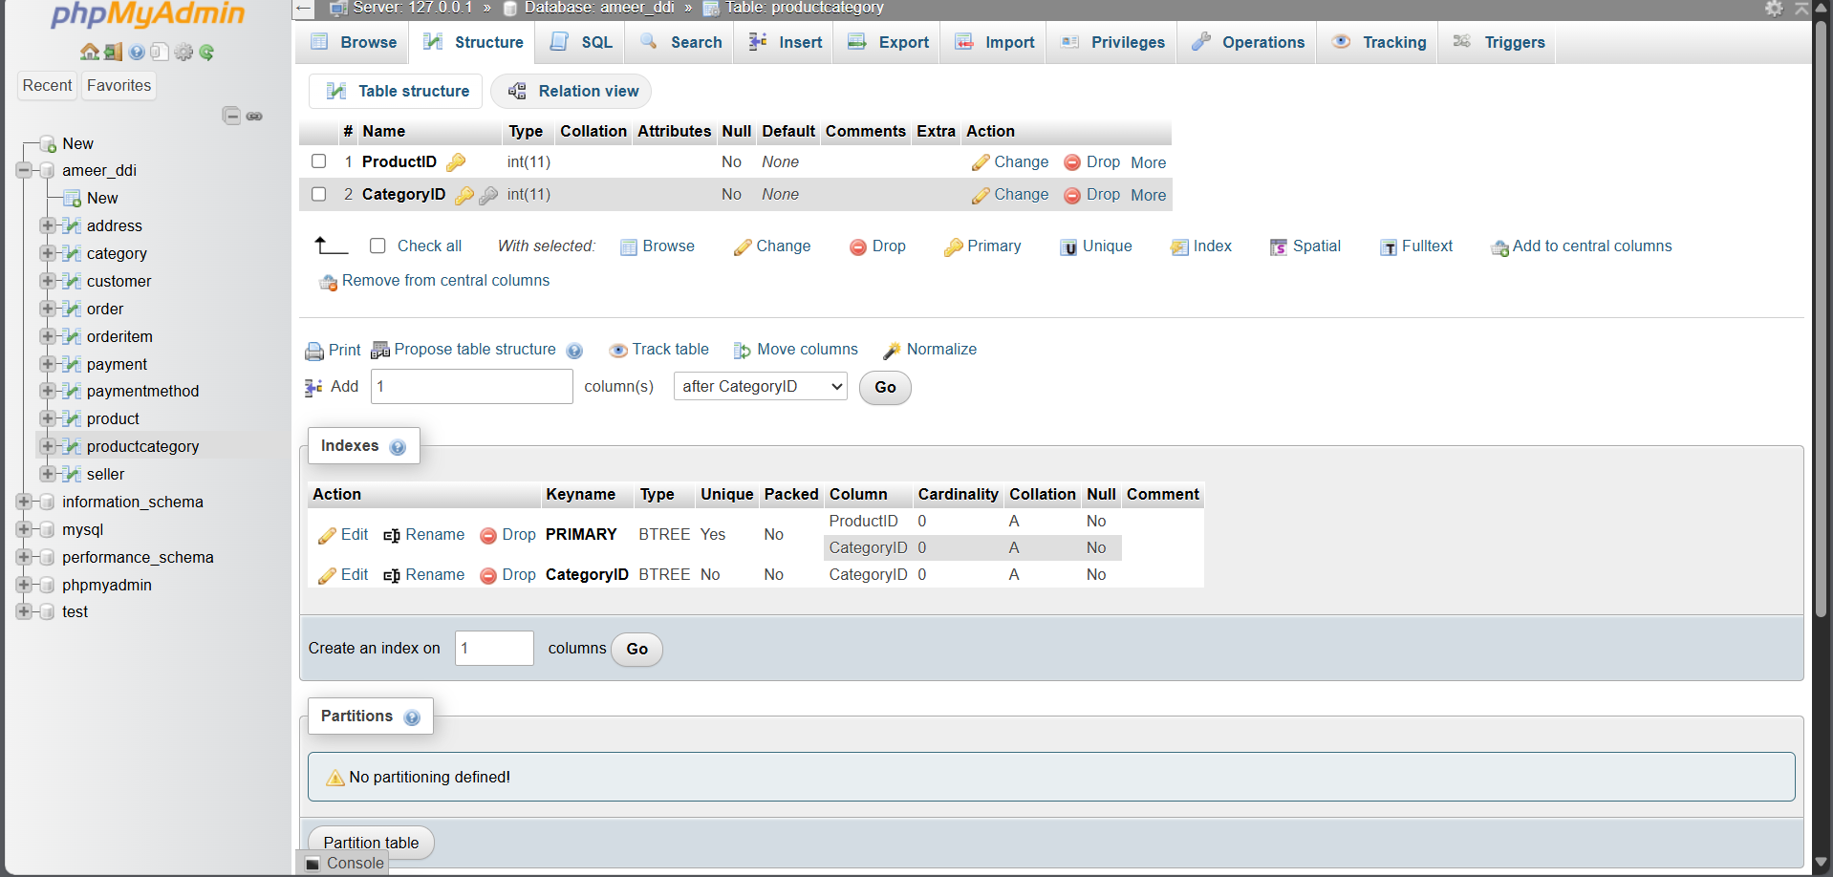

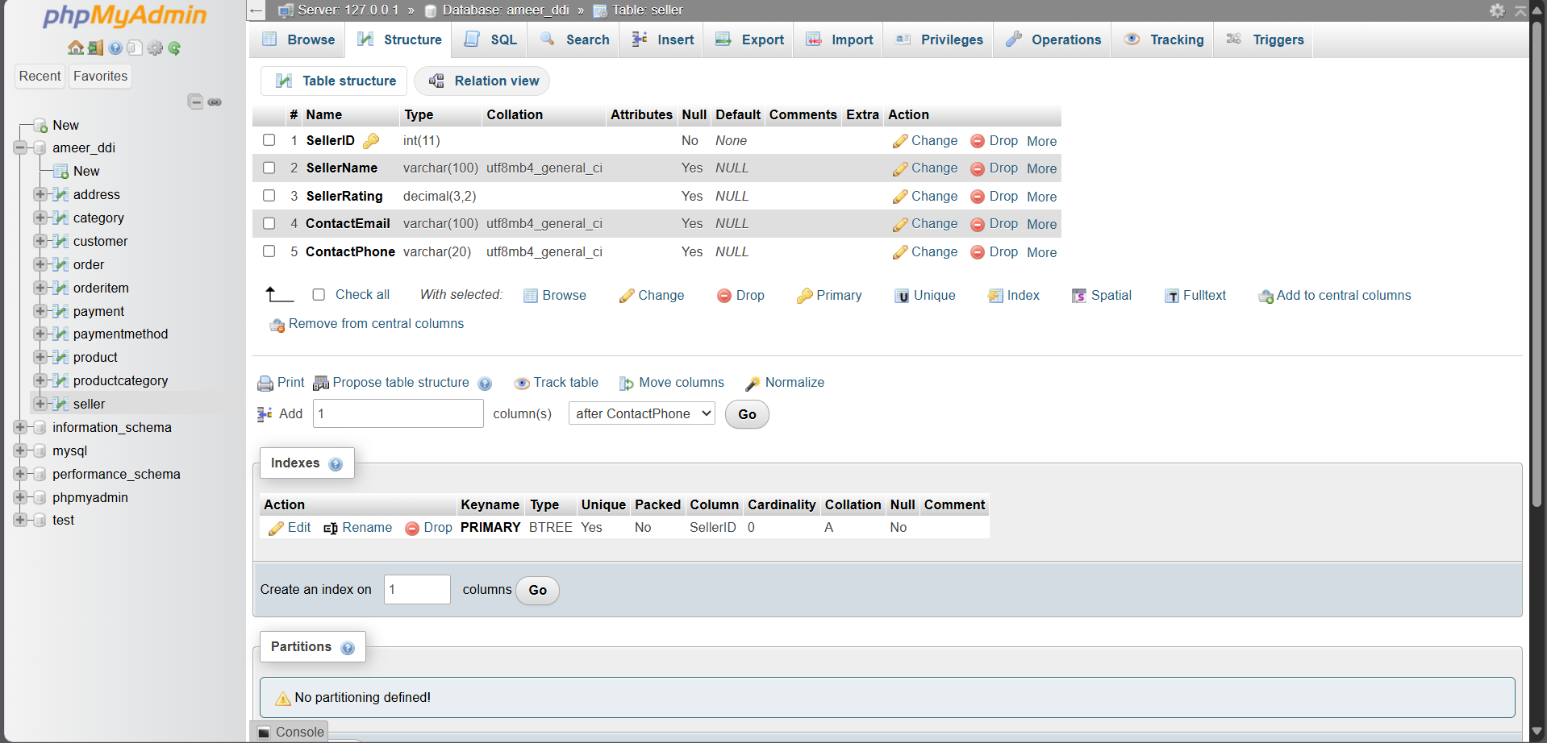

## 3.2 Referential Integrity Enforcement

All relationships were declared using FOREIGN KEY (...) REFERENCES ... syntax, and the integrity was tested by:

* Deleting a parent record and checking child deletion (Order → OrderItem)
* Inserting mismatched foreign keys (e.g., non-existent CustomerID) to confirm constraints

**Failed INSERT with invalid foreign key**

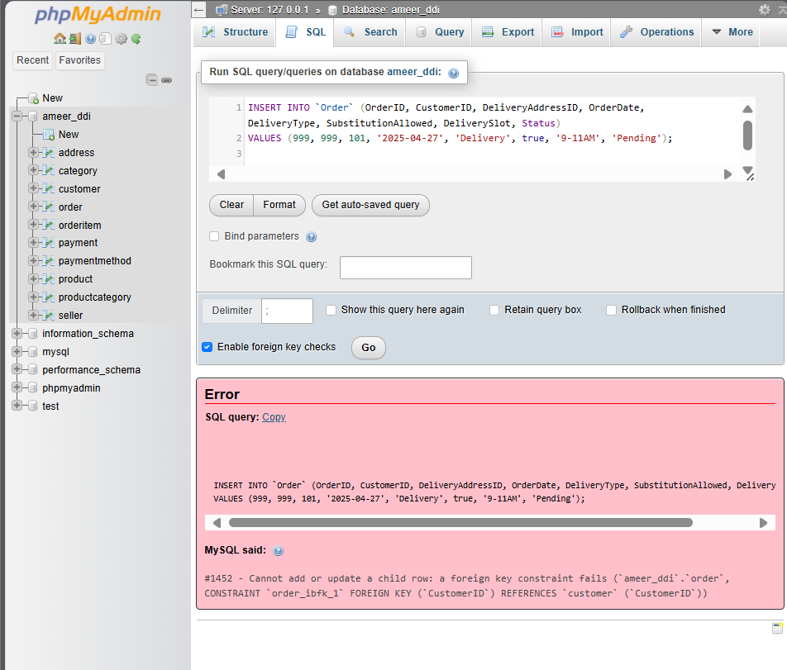  
MySQL rejected insert due to integrity enforcement — proving FK works

## 3.3 Sample Data Insertion

Each table was populated with **at least six rows** of meaningful data that aligns with real-world use cases. Sample values were consistent and valid to ensure joins and queries work as expected.

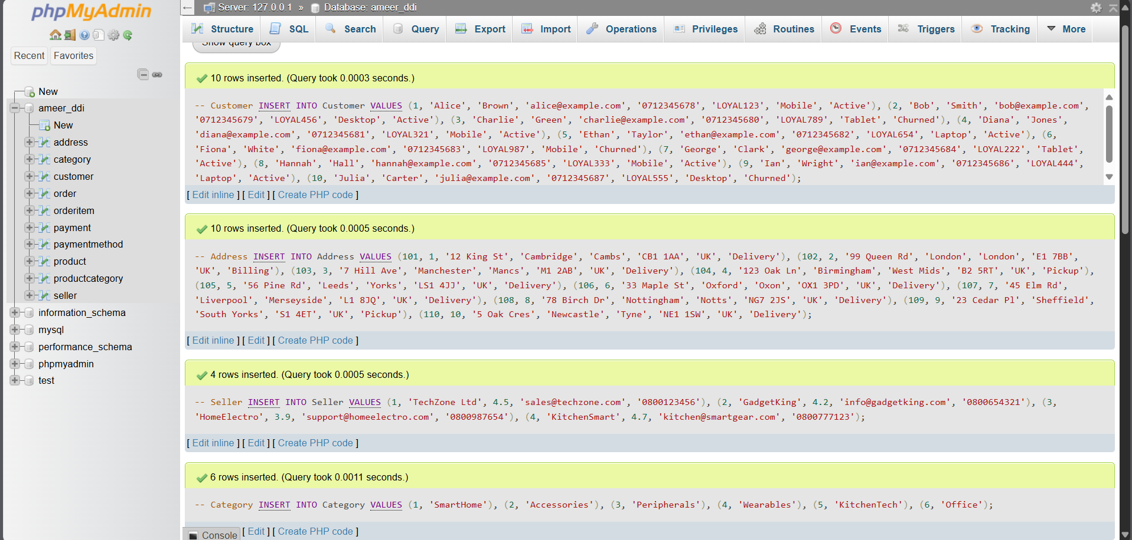 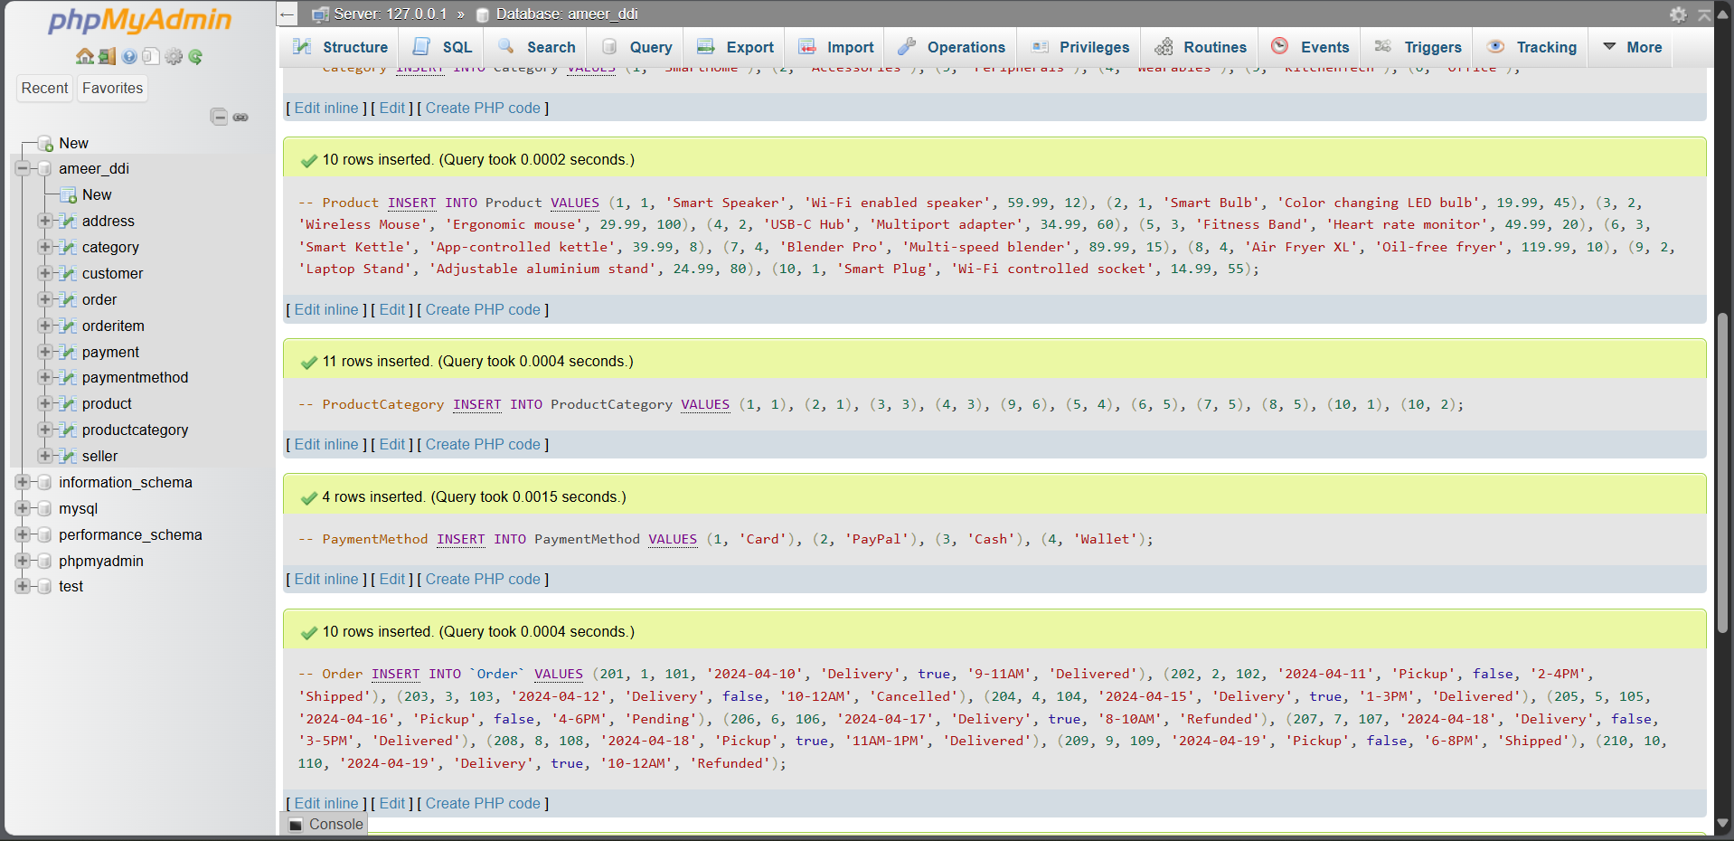 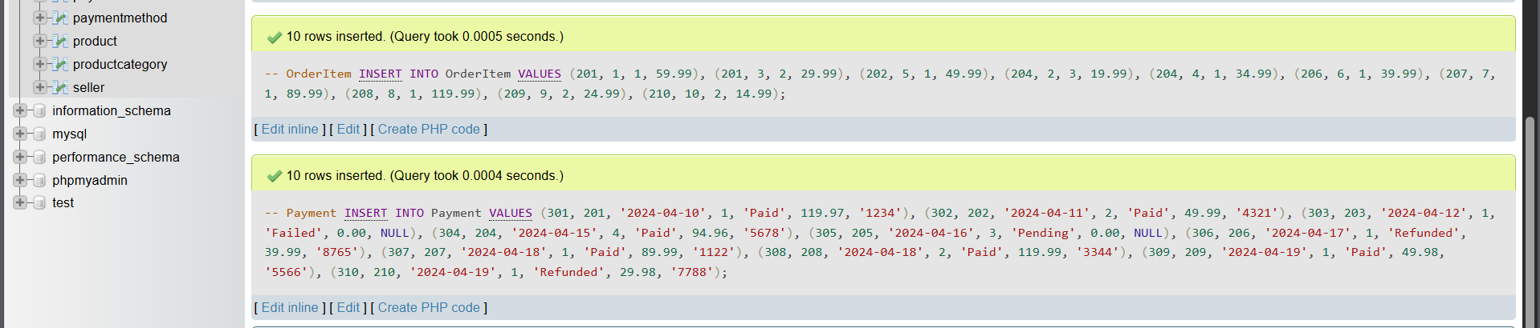

**Workbench result: SELECT * FROM Customer**

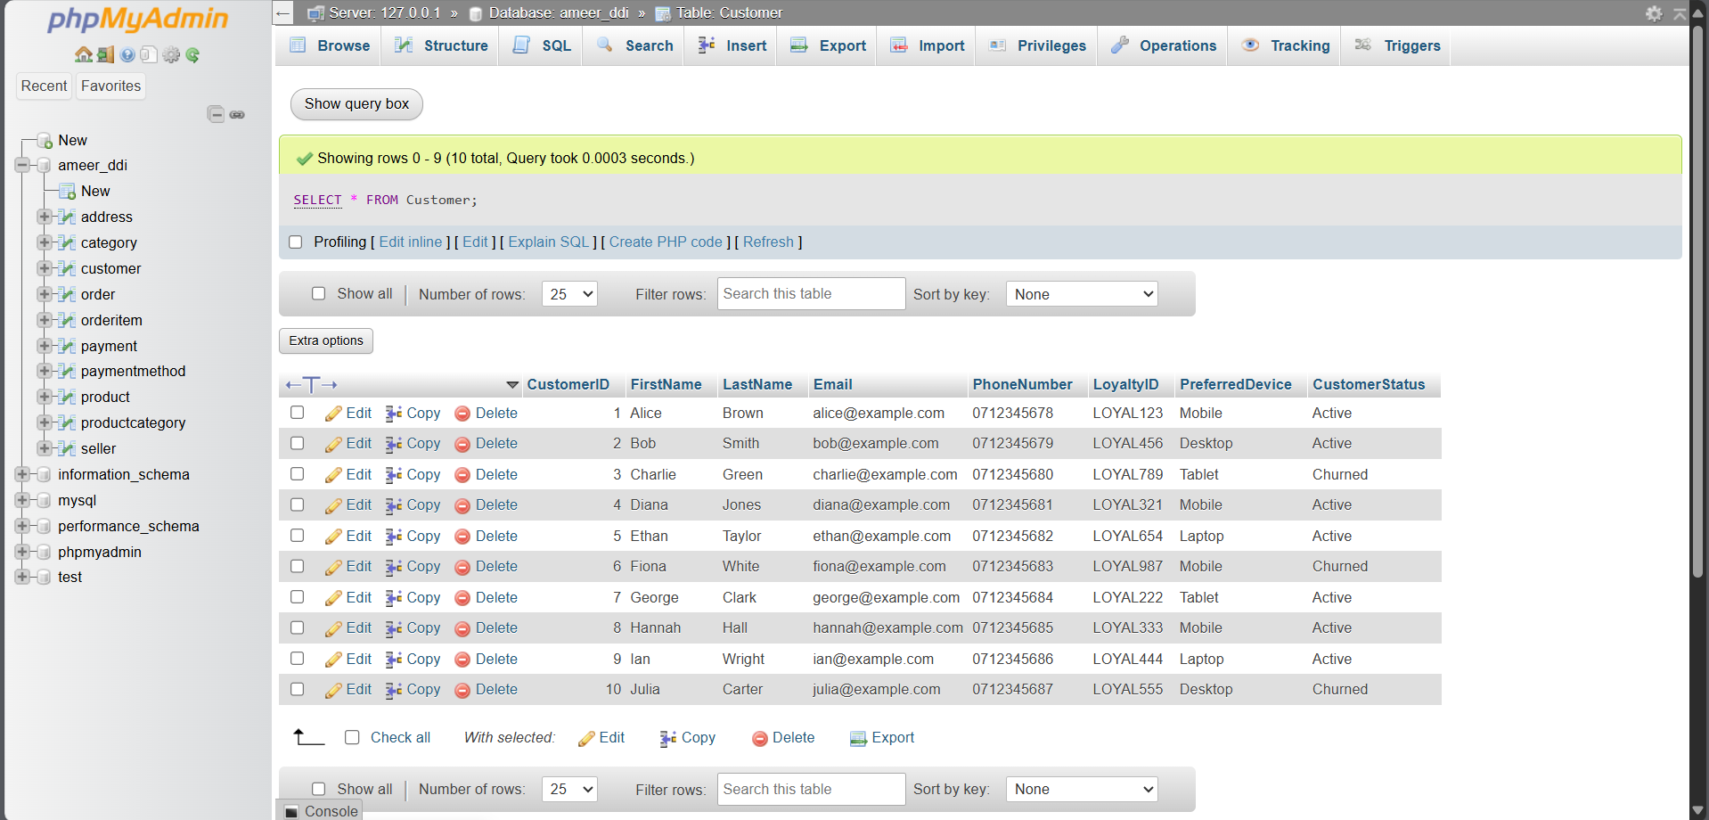  
Customer data inserted, showing full structure including Loyalty ID

Showing all :

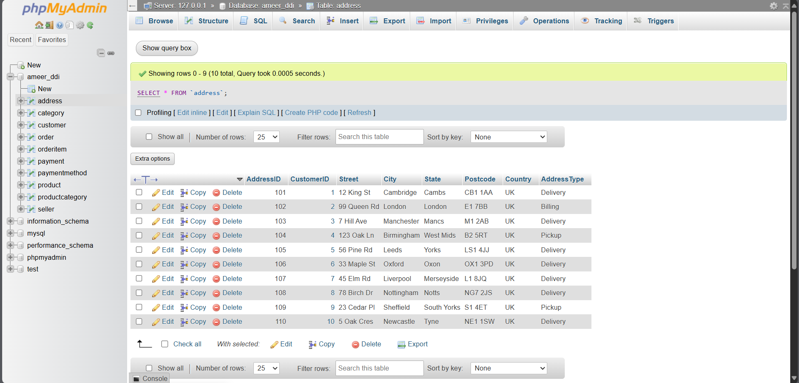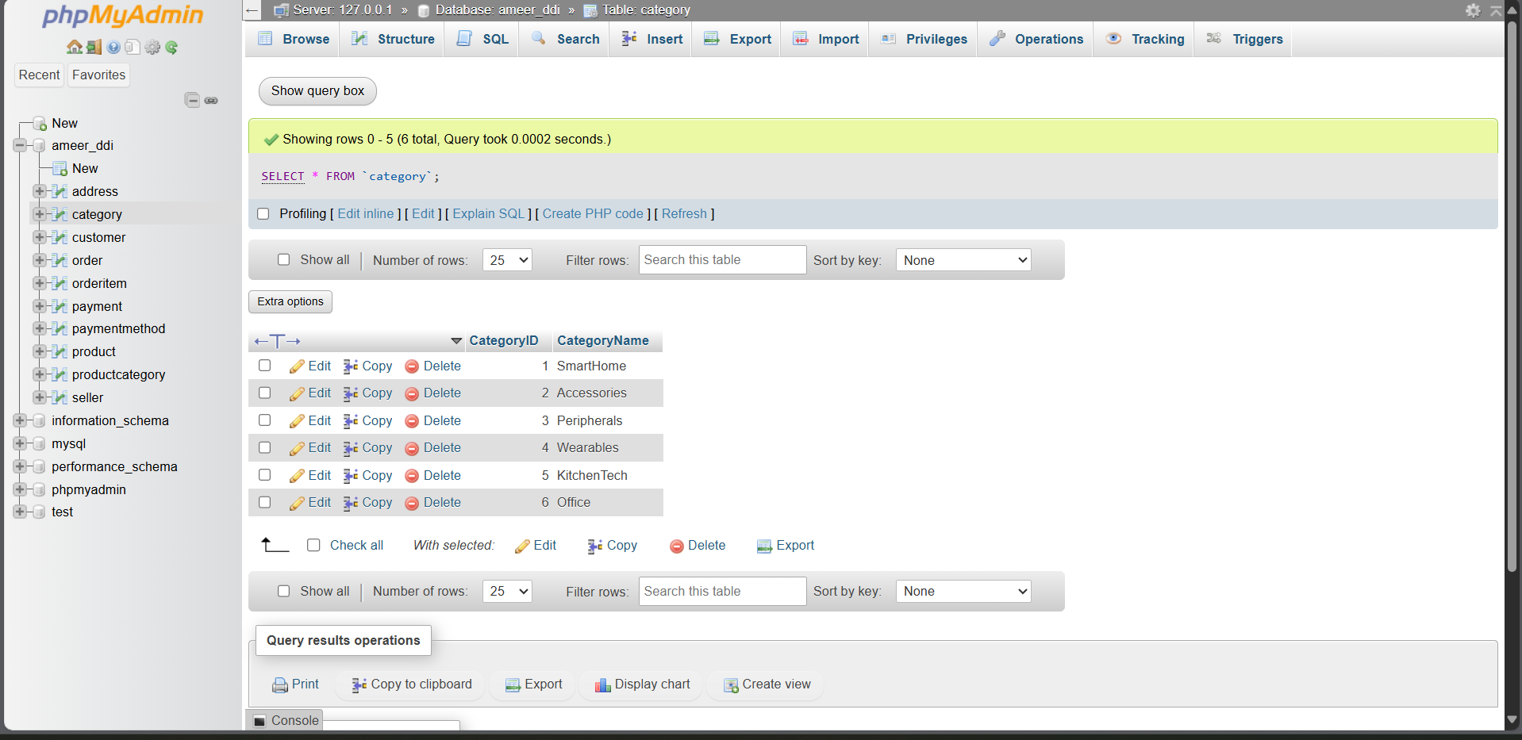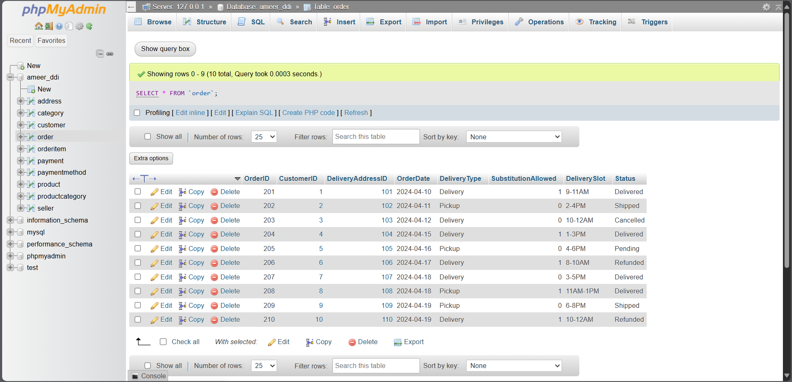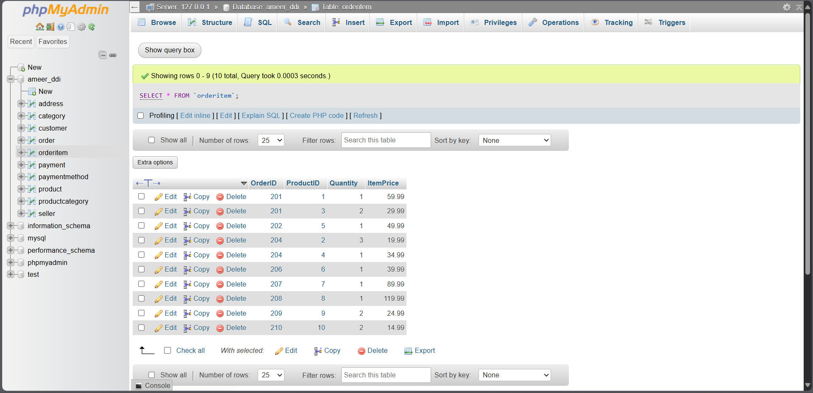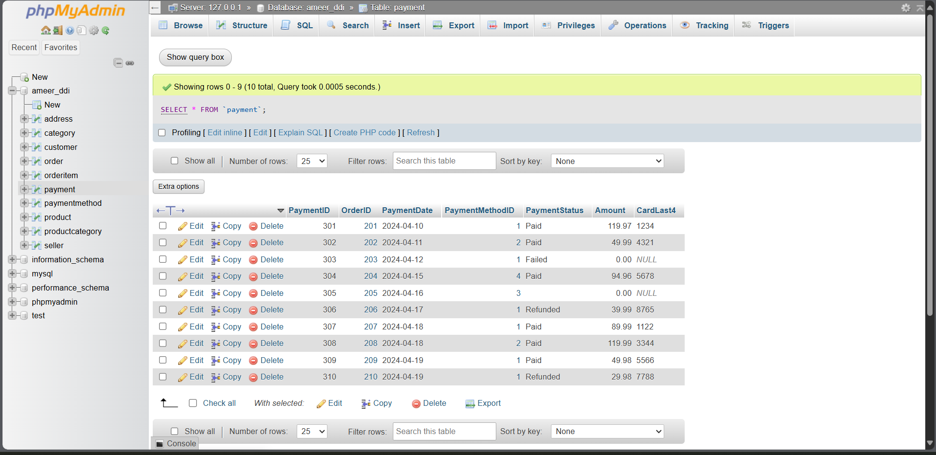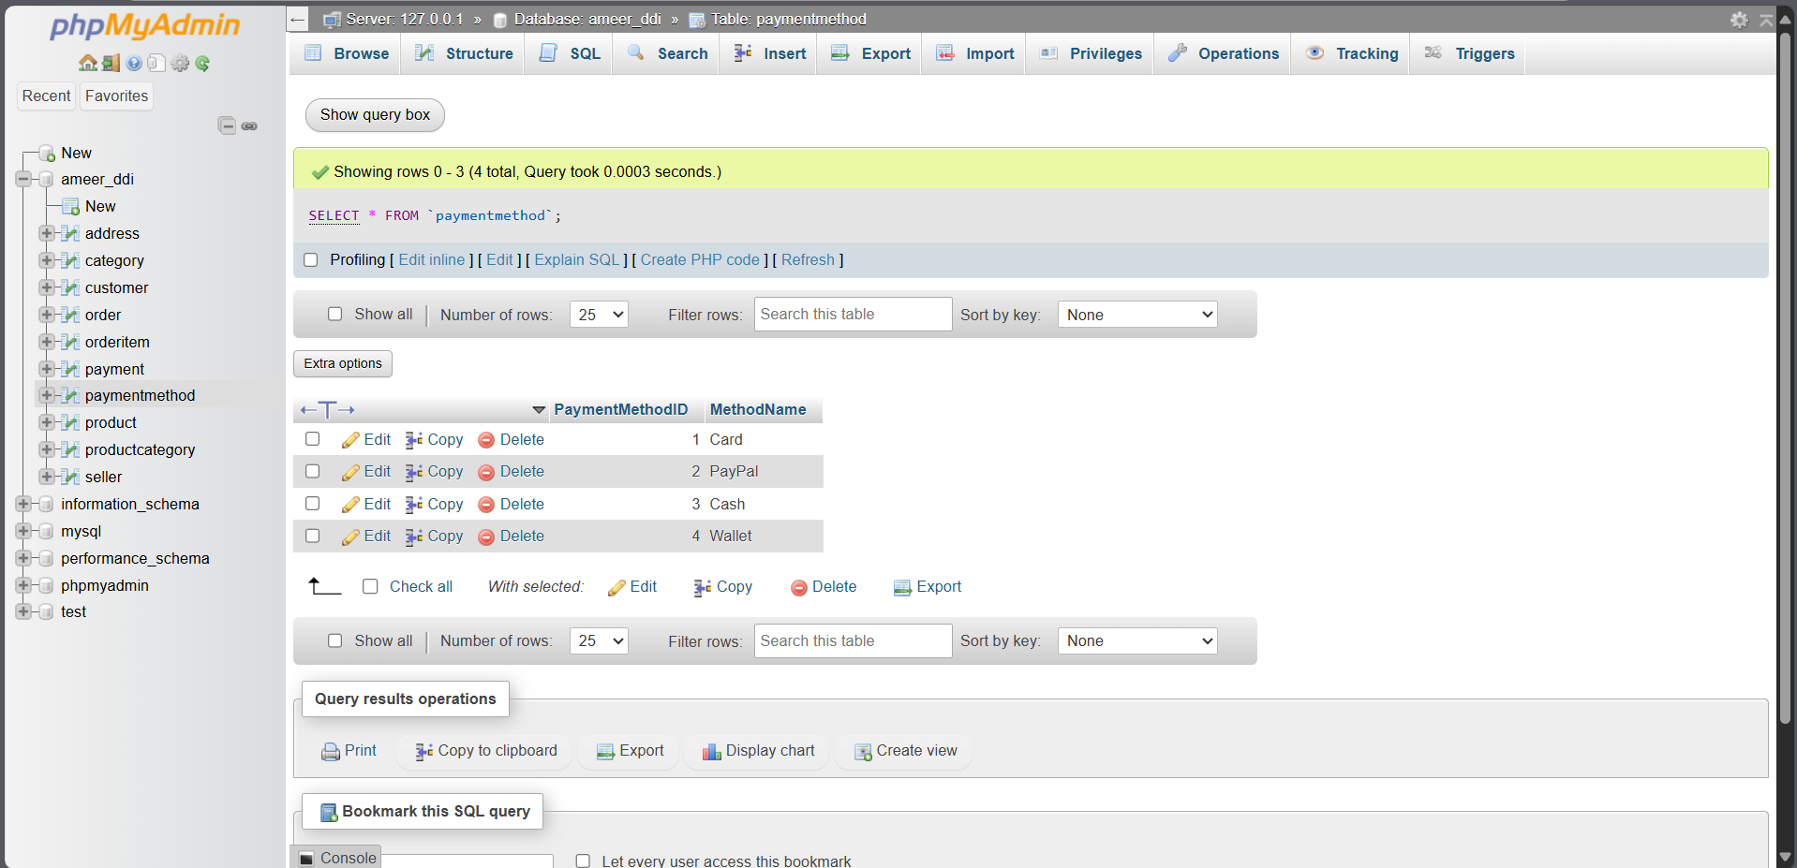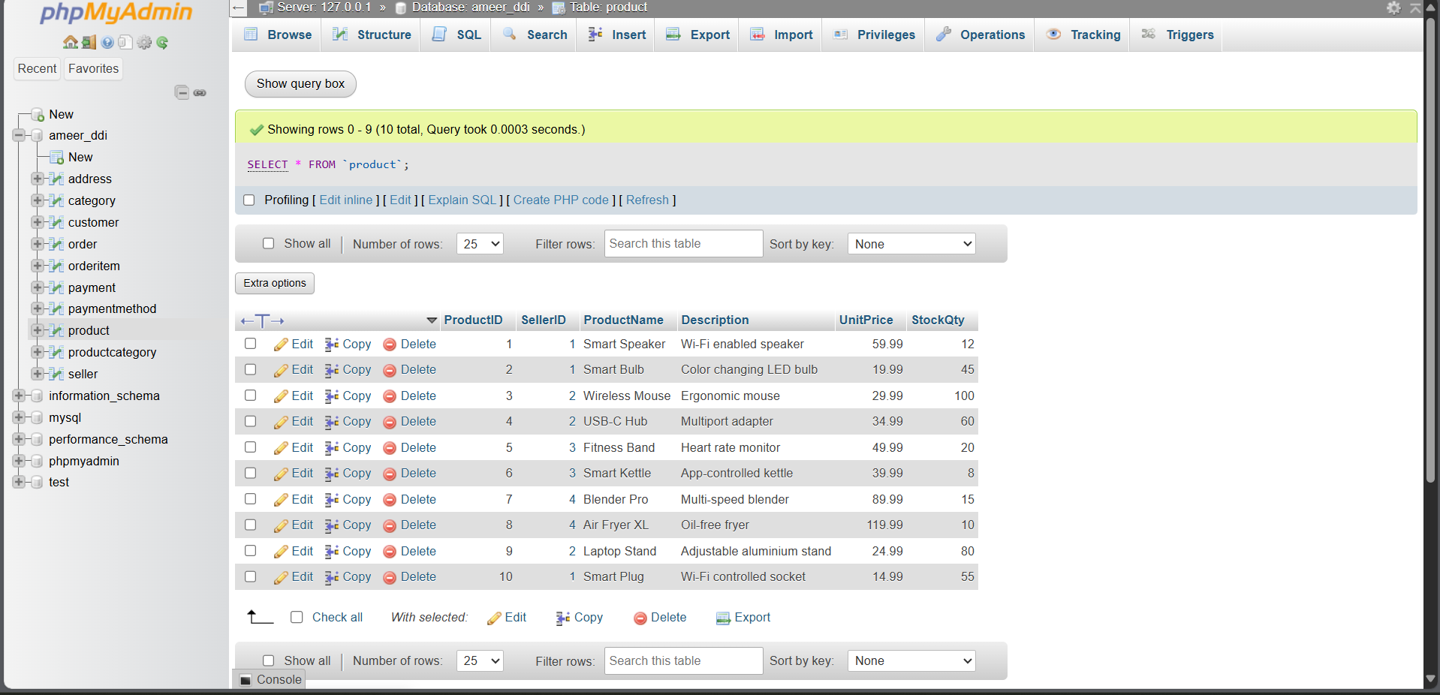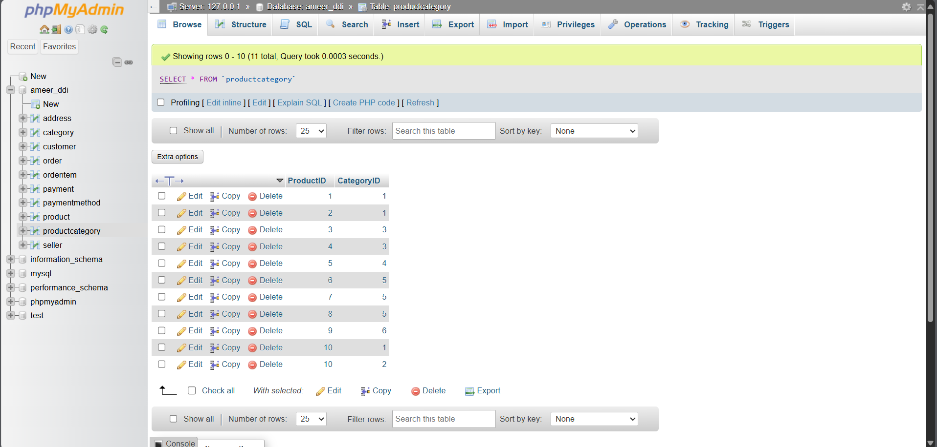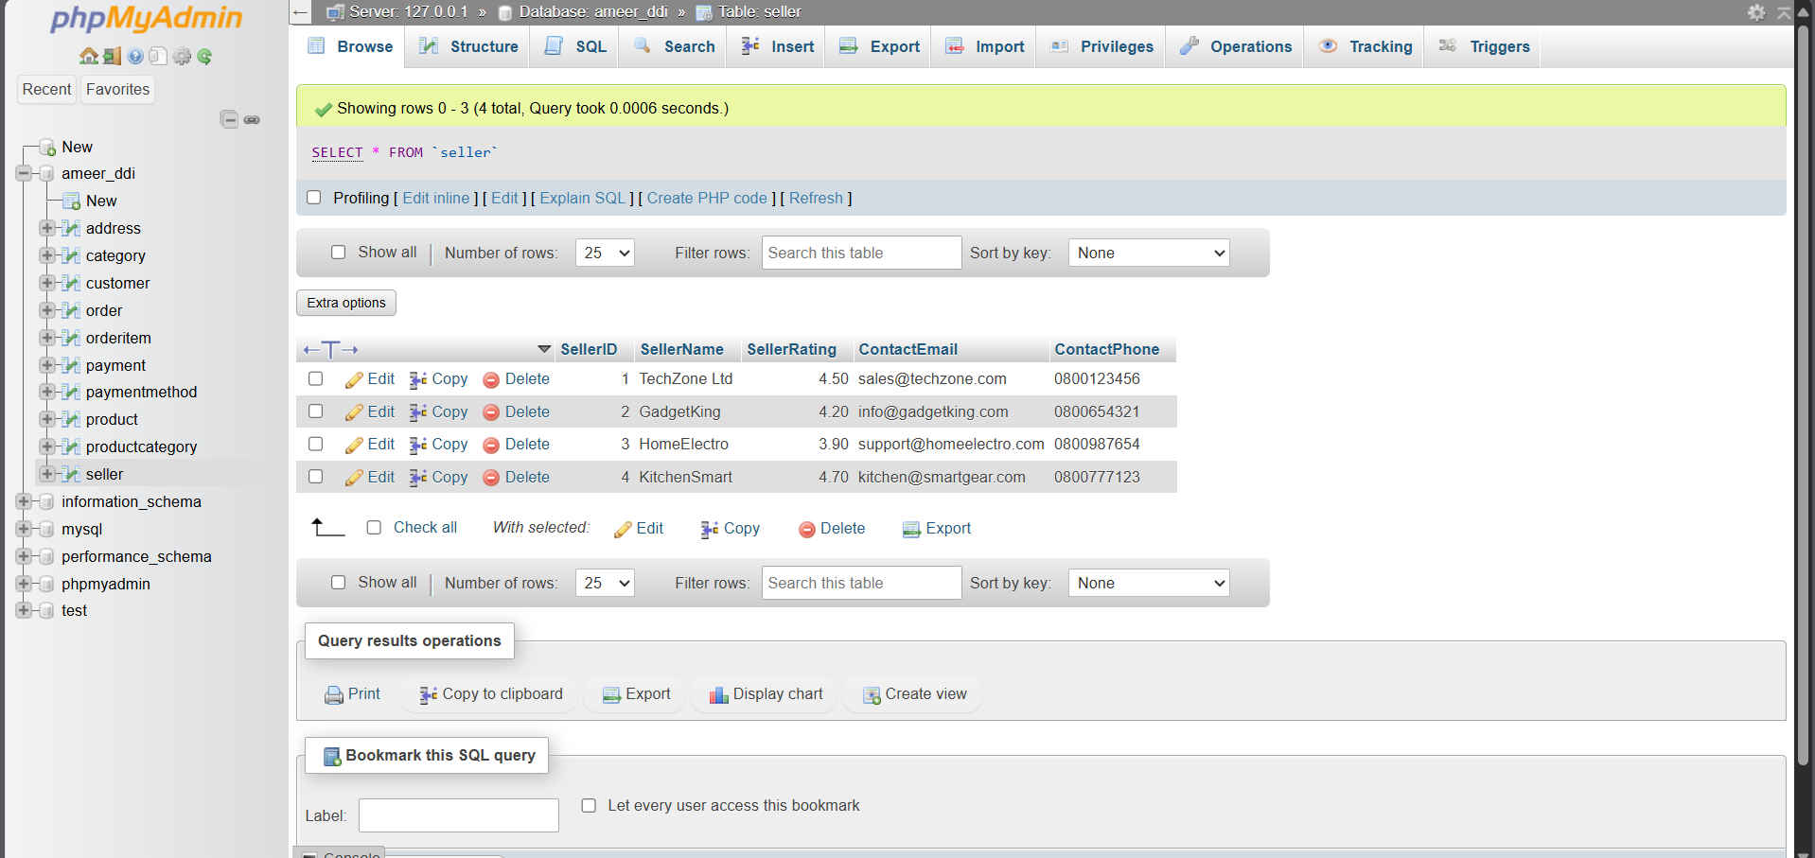

**Workbench result: SELECT * FROM OrderItem**

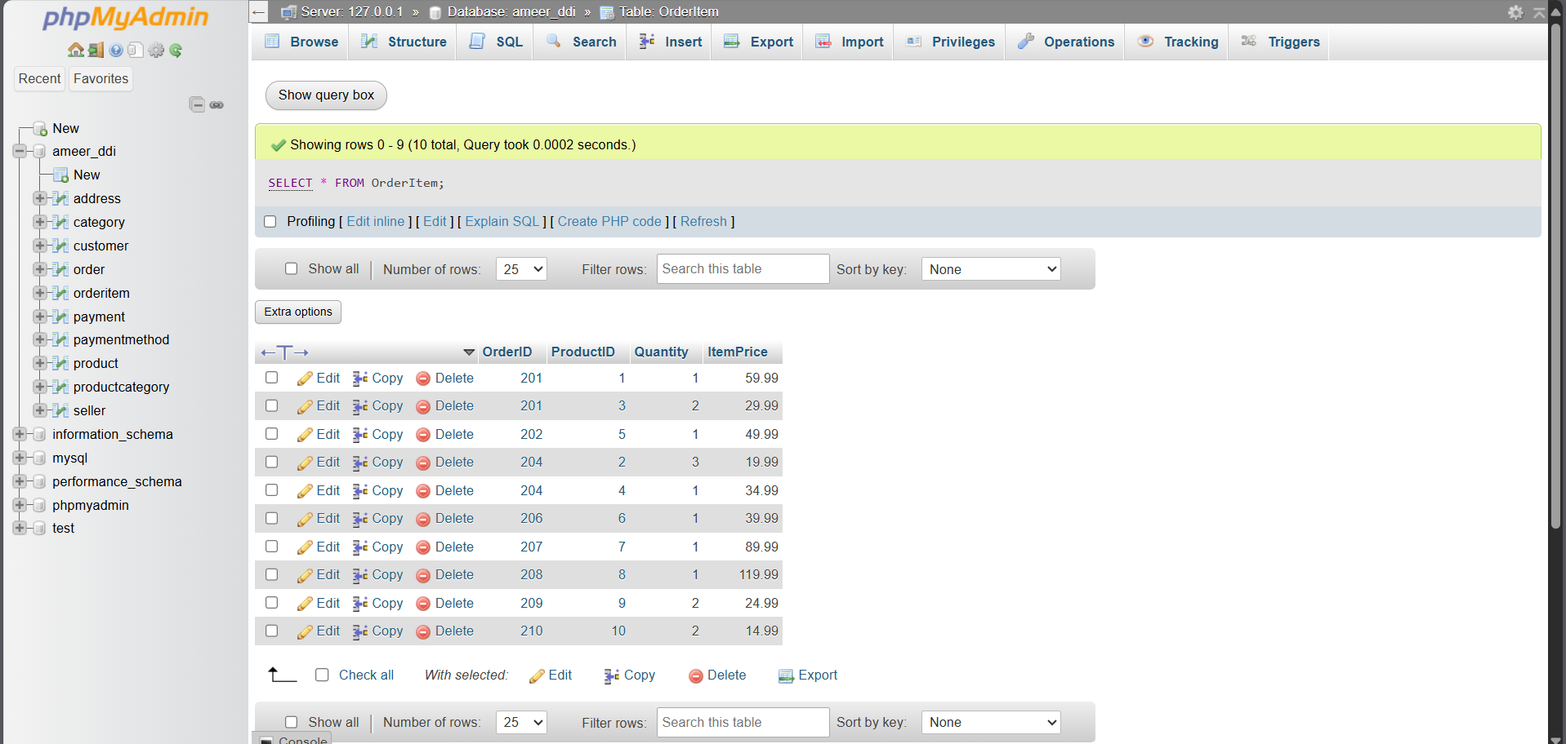  
Shows valid composite keys and foreign-key-aligned Product/Order IDs

**Workbench ERD view showing table connections**

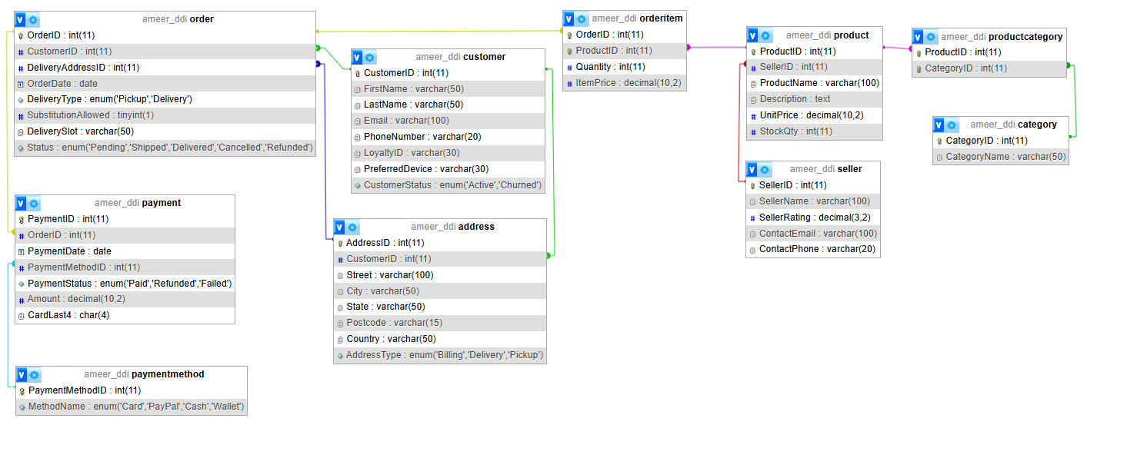   
Highlights all relationships drawn with FK lines between tables

## **3.4 Relationship Validation**

Foreign key relationships were visualised using **XAMPP ERD diagram** feature to verify:

* Connections between Customer → Order
* Connections between Product ↔ Category (via ProductCategory)
* Aggregation and composition semantics:
  + Payment aggregates Order
  + OrderItem is a composition of Order

**Full ERD with FK relationship lines**

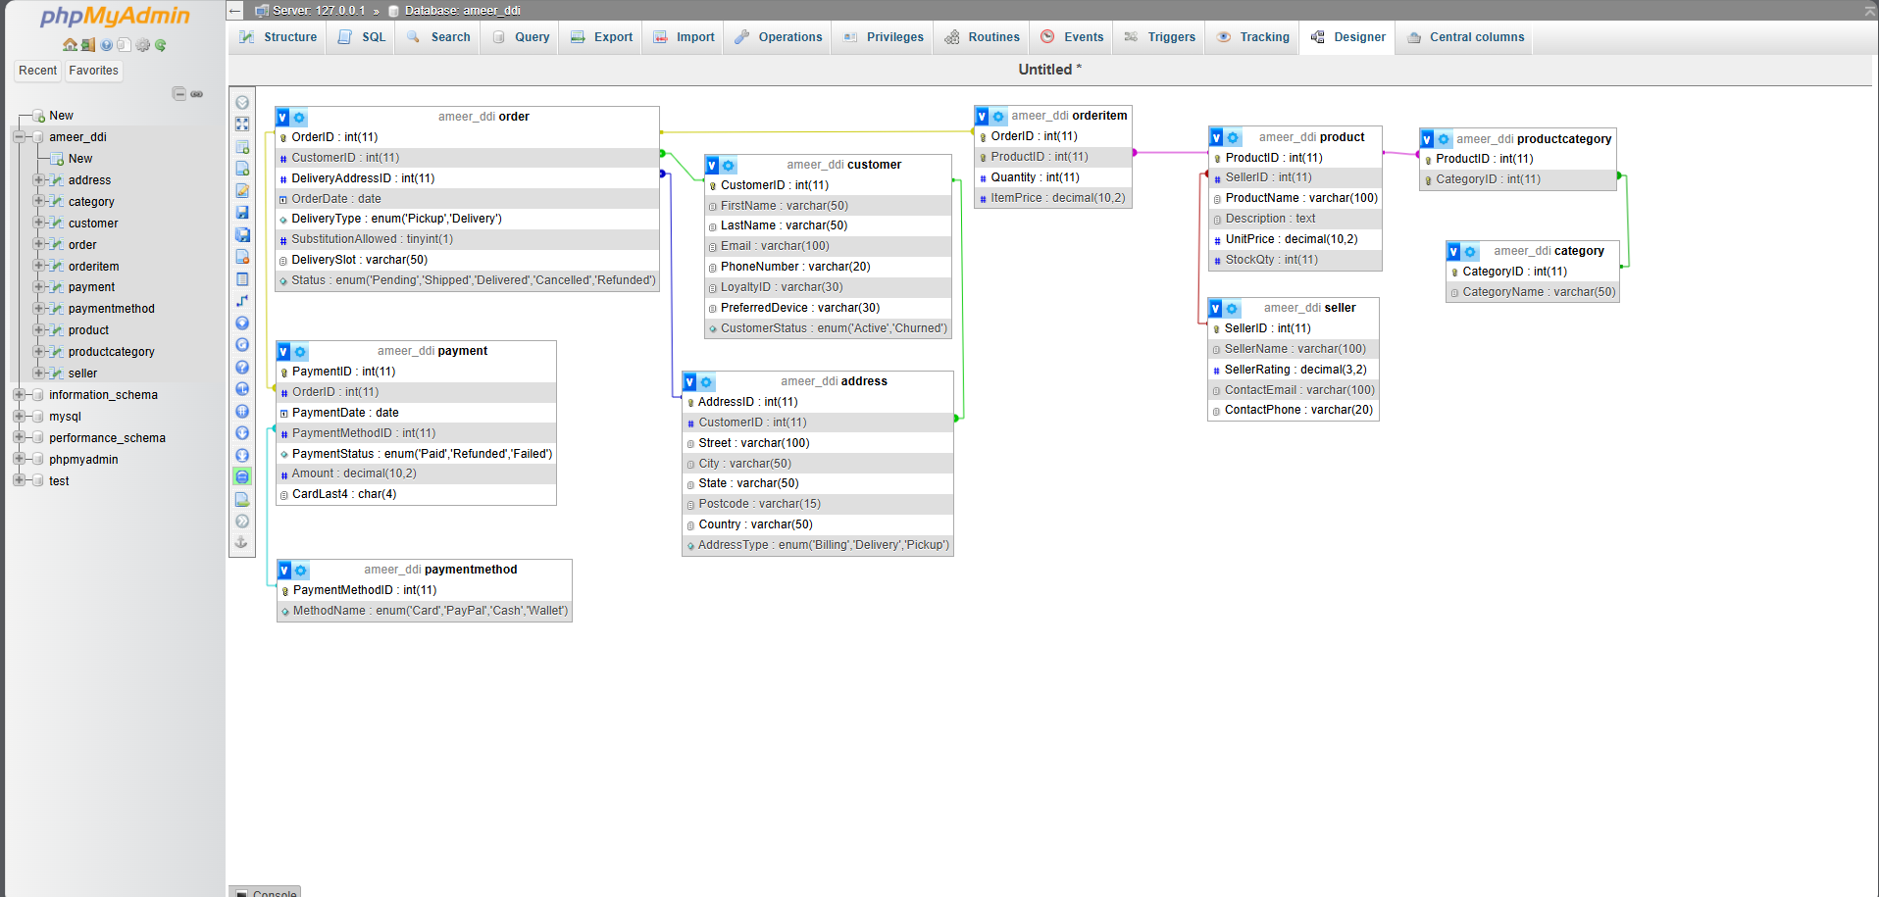  
Annotation: All FKs correctly show connections. Parent-child rules confirmed visually.

# 

# 4. SQL Queries

## 4.1 Query 1

### 4.1.1 Purpose

To identify which customers are most active based on their order frequency within the last 3 months.

### 4.1.2 Natural language

List customers with number of orders in the last 90 days.

### 4.1.3 SQL Code and output

Code:

SELECT c.CustomerID,

CONCAT(c.FirstName, ' ', c.LastName) AS CustomerName,

COUNT(o.OrderID) AS TotalOrders

FROM Customer c

JOIN `Order` o ON c.CustomerID = o.CustomerID

WHERE o.OrderDate >= DATE_SUB(CURDATE(), INTERVAL 90 DAY)

GROUP BY c.CustomerID

ORDER BY TotalOrders DESC;

Output: 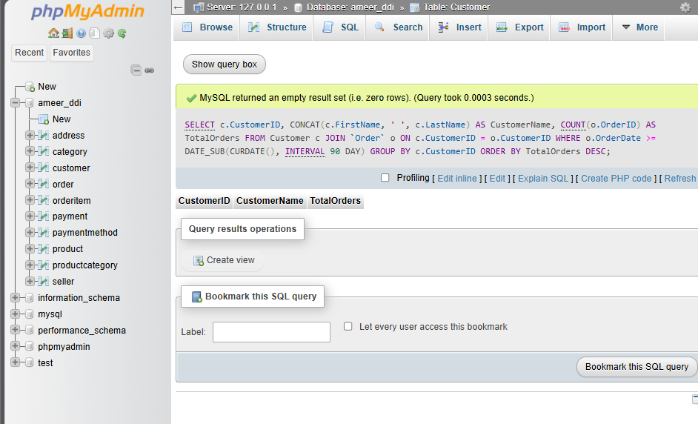

### 4.1.4 Explanation

This query reveals the most loyal or active customers in recent months valuable for loyalty rewards, targeted email campaigns, or upselling.

## 4.2 Query 2

### 4.2.1 Purpose

To determine which product categories have generated the most revenue.

### 4.2.2 Natural language

Which categories have produced the highest sales in terms of revenue?

### 4.2.3 SQL Code and output

Code:

SELECT cat.CategoryName,

SUM(oi.Quantity * oi.ItemPrice) AS TotalRevenue

FROM OrderItem oi

JOIN Product p ON oi.ProductID = p.ProductID

JOIN ProductCategory pc ON p.ProductID = pc.ProductID

JOIN Category cat ON pc.CategoryID = cat.CategoryID

GROUP BY cat.CategoryName

ORDER BY TotalRevenue DESC

LIMIT 5;

Output: 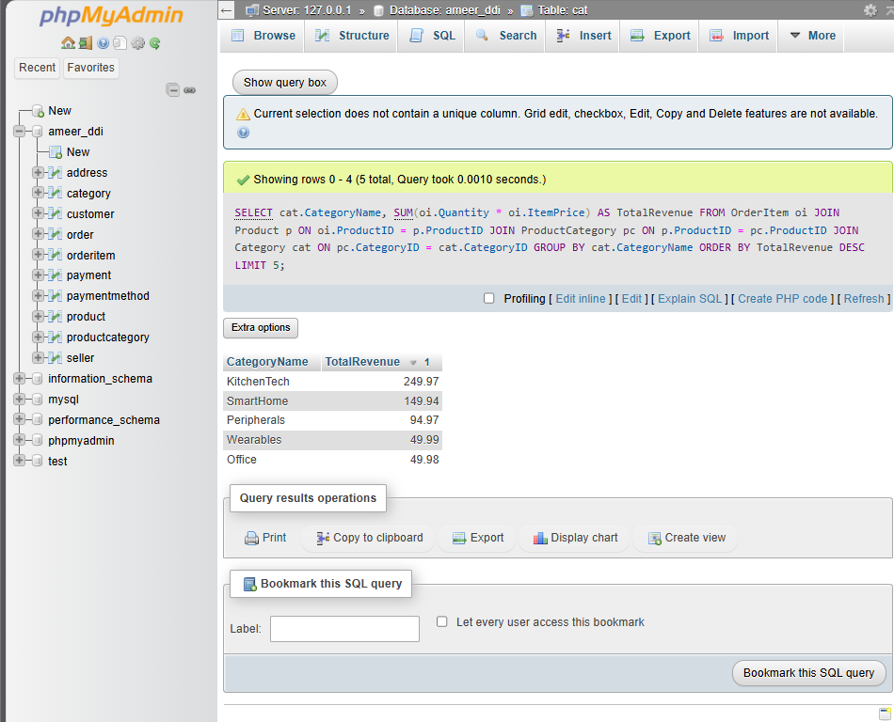

### 4.2.4 Explanation

This helps the business focus marketing efforts on top-performing categories and identify which inventory to stock more heavily.

## 4.3 Query 3

## 4.3.1 Purpose

To assess customer basket size and order value key metrics for upselling.

### 4.3.2 Natural language

What is the average number of items and average value per order?

### 4.3.3 SQL Code and output

Code:

SELECT AVG(item_count) AS AvgItemsPerOrder,

AVG(total_price) AS AvgOrderValue

FROM (

SELECT o.OrderID,

SUM(oi.Quantity) AS item_count,

SUM(oi.Quantity * oi.ItemPrice) AS total_price

FROM `Order` o

JOIN OrderItem oi ON o.OrderID = oi.OrderID

GROUP BY o.OrderID

) AS order_summary;

Output: 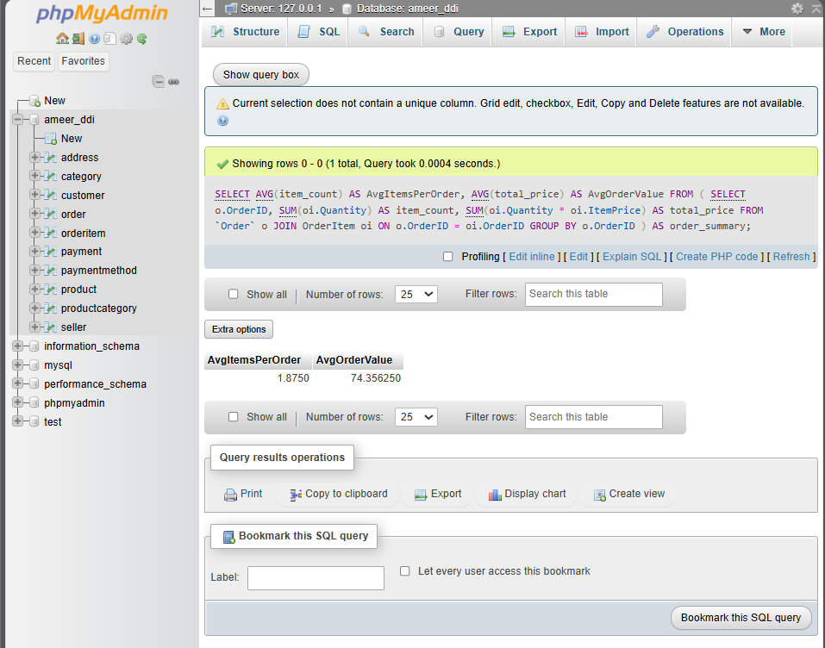

### 4.3.4 Explanation

Useful for understanding customer behavior — e.g., whether bundling offers might increase order size.

## 4.4 Query 4

### 4.4.1 Purpose

To automatically flag low-stock items for supplier reordering.

### 4.4.2 Natural language

Which products have a stock level below 10 units?

### 4.4.3 SQL Code and output

Code:

SELECT p.ProductID,

p.ProductName,

p.StockQty,

s.SellerName,

s.ContactEmail

FROM Product p

JOIN Seller s ON p.SellerID = s.SellerID

WHERE p.StockQty < 10

ORDER BY p.StockQty ASC;

Output : 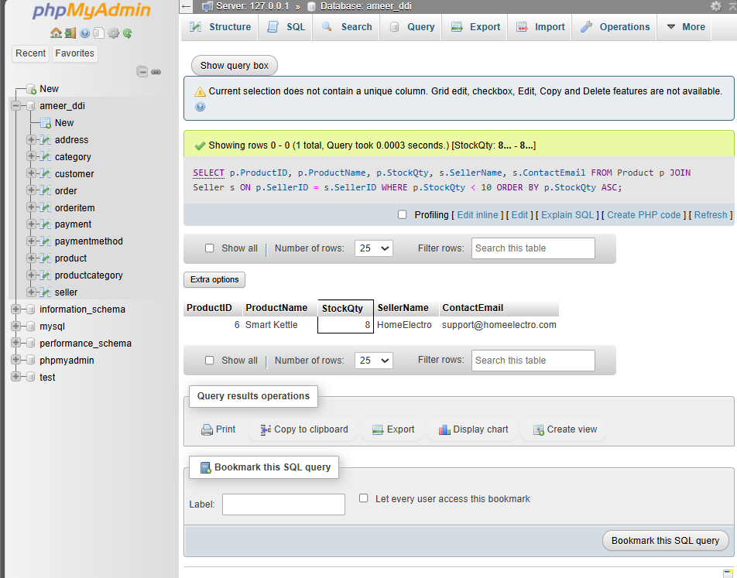

### 4.4.4 Explanation

This helps avoid stockouts and lost sales, and triggers vendor contact for restocking.

## 4.5 Query 5

### 4.5.1 Purpose

To evaluate the reliability and refund risk associated with different payment methods.

### 4.5.2 Natural language

What is the refund rate per payment method?

### 4.5.3 SQL Code and output

Code:

SELECT pm.MethodName,

COUNT(*) AS TotalTransactions,

SUM(CASE WHEN p.PaymentStatus = 'Refunded' THEN 1 ELSE 0 END) AS RefundedCount,

ROUND(100 * SUM(CASE WHEN p.PaymentStatus = 'Refunded' THEN 1 ELSE 0 END) / COUNT(*), 2) AS RefundRate

FROM Payment p

JOIN PaymentMethod pm ON p.PaymentMethodID = pm.PaymentMethodID

GROUP BY pm.MethodName;

Output: 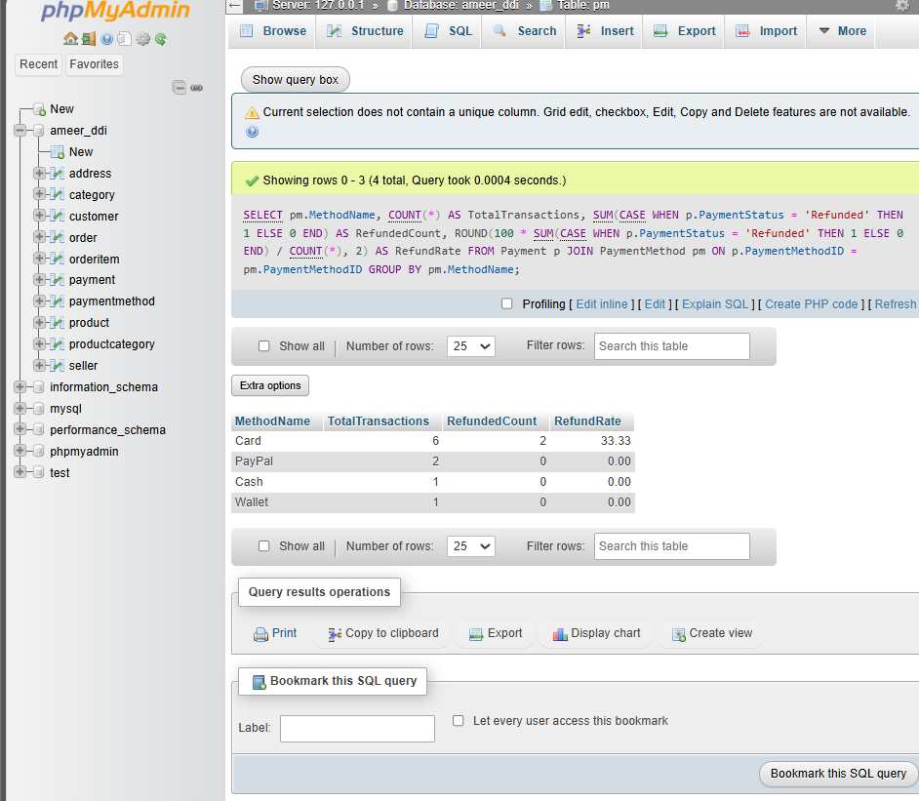

### 4.5.4 Explanation

This helps the finance team detect risky or less trusted payment types and adjust fraud controls.

## 4.6 Query 6

### 4.6.1 Purpose

To determine the highest-selling products based on units sold.

### 4.6.2 Natural language

Which products have sold the most units across all orders?

### 4.6.3 SQL Code and output

Code:

SELECT p.ProductID,

p.ProductName,

SUM(oi.Quantity) AS UnitsSold

FROM OrderItem oi

JOIN Product p ON oi.ProductID = p.ProductID

GROUP BY p.ProductID, p.ProductName

ORDER BY UnitsSold DESC

LIMIT 5;

Output: 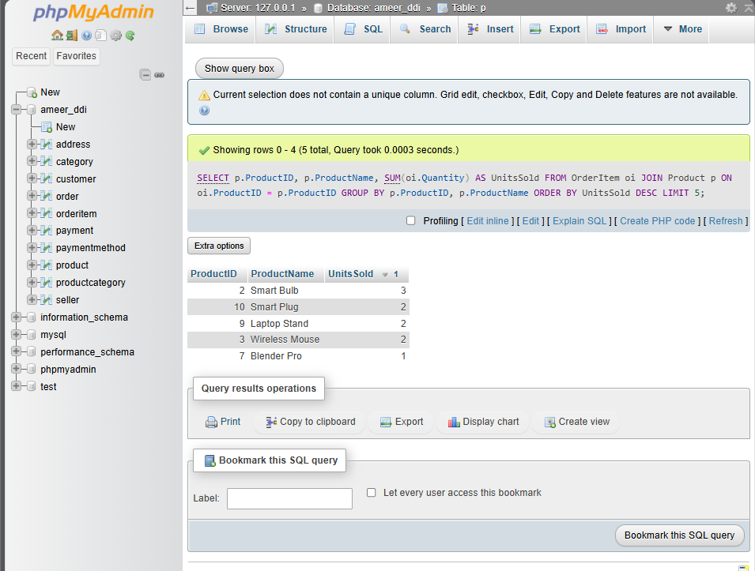

### 4.6.4 Explanation

This query reveals which products are in highest demand, guiding purchasing, promotions, and pricing strategies.

## 4.7 Query 7

### 4.7.1 Purpose

To identify the top-spending customers to prioritize for VIP loyalty programs.

### 4.7.2 Natural language

Which customers have spent the most across all their orders?

### 4.7.3 SQL Code and output

Code:

SELECT c.CustomerID,

CONCAT(c.FirstName, ' ', c.LastName) AS CustomerName,

SUM(oi.Quantity * oi.ItemPrice) AS TotalSpent

FROM Customer c

JOIN `Order` o ON c.CustomerID = o.CustomerID

JOIN OrderItem oi ON o.OrderID = oi.OrderID

GROUP BY c.CustomerID

ORDER BY TotalSpent DESC

LIMIT 5;

Output: 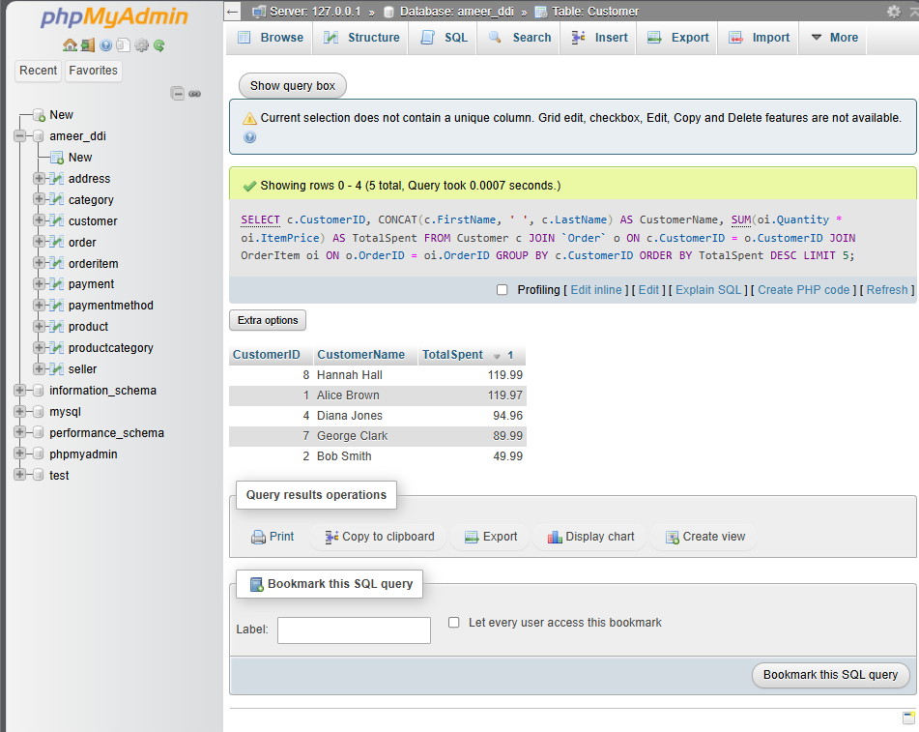

### 4.7.4 Explanation

These are high-value customers they may warrant personalized campaigns, discounts, or exclusive access to products.

## 4.8 Query 8

### 4.8.1 Purpose

To assess the average time taken to complete a paid order.

### 4.8.2 Natural language

What is the average number of days between order placement and payment completion?

### 4.8.3 SQL Code and output

Code:

SELECT ROUND(AVG(DATEDIFF(p.PaymentDate, o.OrderDate)), 2) AS AvgProcessingTimeDays

FROM `Order` o

JOIN Payment p ON o.OrderID = p.OrderID

WHERE p.PaymentStatus = 'Paid';

Output : 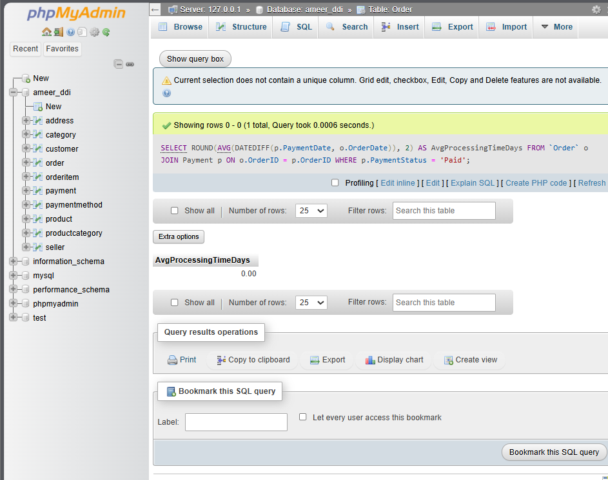

### 4.8.4 Explanation

Helps evaluate system and logistics delays — if average days are high, investigate payment or fulfillment bottlenecks.

## 4.9 Query 9

### 4.9.1 Purpose

To understand how many customers prefer pickup versus delivery, over time.

### 4.9.2 Natural language

How many orders were placed as Pickup vs Delivery each month?

### 4.9.3 SQL Code and output

Code:

SELECT MONTH(o.OrderDate) AS OrderMonth,

o.DeliveryType,

COUNT(*) AS OrderCount

FROM `Order` o

GROUP BY OrderMonth, o.DeliveryType

ORDER BY OrderMonth;

Output : 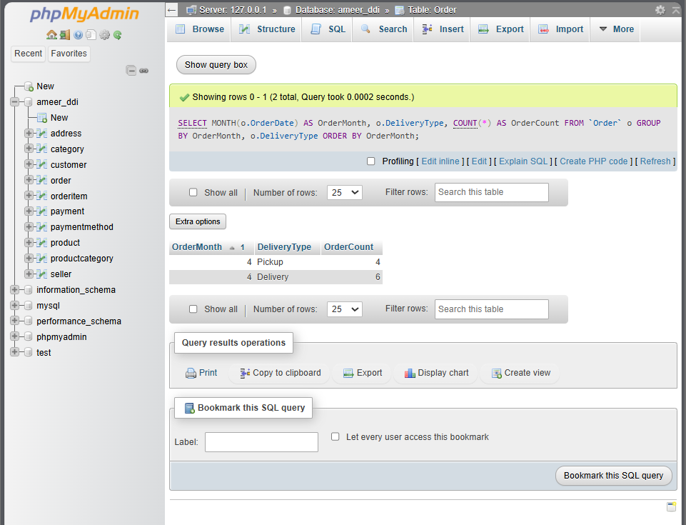

### 4.9.4 Explanation

Business can align delivery or in-store staff schedules based on customer preferences by month or season.

## 4.10 Query 10

### 4.10.1 Purpose

To estimate revenue loss caused by refunds.

### 4.10.2 Natural language

What is the total refunded amount across all transactions?

### 4.10.3 SQL Code and output

Code:

SELECT SUM(p.Amount) AS TotalRefundedAmount

FROM Payment p

WHERE p.PaymentStatus = 'Refunded';

Output: 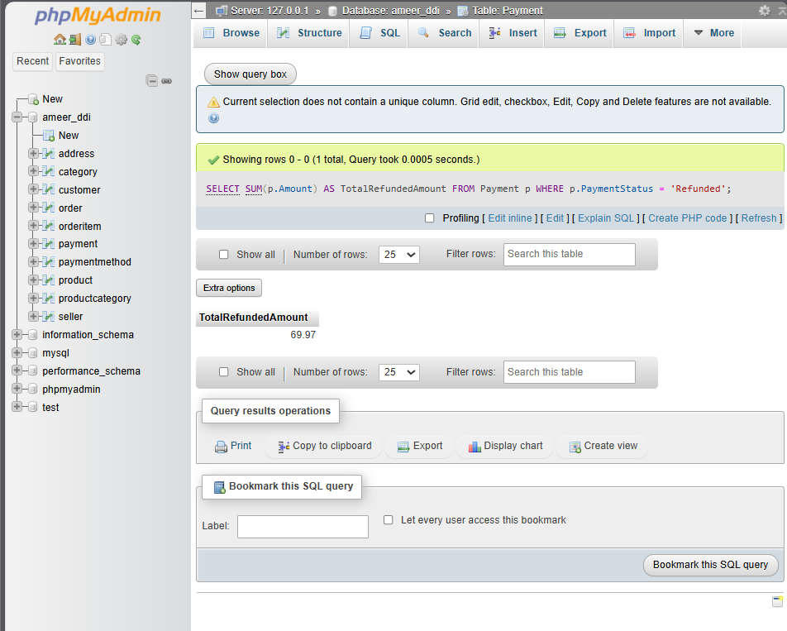

### 4.10.4 Explanation

Provides the finance or product team with visibility into how much money was returned to customers helps fine-tune return policies and product quality.

# 

# 5. References

Amazon, 2025. *Amazon UK – Online Shopping Site*. [online] Available at: <https://www.amazon.co.uk>

Date, C.J., 2019. *An introduction to database systems*. 9th ed. Boston: Addison-Wesley.

eBay, 2025. *eBay UK – Buy and Sell Electronics, Fashion, Home & More*. [online] Available at: <https://www.ebay.co.uk>

Elmasri, R. and Navathe, S., 2020. *Fundamentals of database systems*. 8th ed. Harlow: Pearson Education.

MySQL, 2025. *MySQL 8.0 Reference Manual*. [online] Available at: <https://dev.mysql.com/doc/>

Ofcom, 2024. *UK E-Commerce Industry Report*. [online] Available at: <https://www.ofcom.org.uk/research-and-data/market-reports>

Oracle, 2025. *MySQL Workbench – Database Design Tool*. [software] Available at: <https://www.mysql.com/products/workbench/>

Sun, P., 2008. *Template for DDI Assignment. Additional Supporting Materials for Chelmsford Campus*. Anglia Ruskin University, Module EJ215004S, Database Design and Implementation.

Walmart, 2025. *Walmart US – Save Money. Live Better*. [online] Available at: <https://www.walmart.com>

XAMPP, 2025. *Apache Friends - XAMPP for MySQL/PHP/Apache*. [software] Available at: <https://www.apachefriends.org>